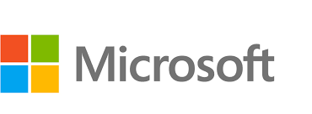

Dynamics 365 Nonprofit Accelerator Deployment Guide

**Published**: December 2020

**Accelerator Release Version**: v3.0

Contents

Nomenclature Update 3

Important Upgrade Considerations (for versions prior to 2.3) 3

Import solutions to CDS 5

Manual Install 5

Importing Sample Data 9

Sample Data Packages to Import 9

Step by step to import packages 10

Create Trial Environment 13

Create Dynamics 365 Company 13

Import solution to Dynamics 365 17

Create new user in Dynamics 365 21

Common Data Model Folder Setup Instructions 23

Prerequisites 23

Create Azure Data Lake Storage Gen2 Storage Account 23

Grant the Power BI Service a Reader Role 28

Identify Power BI Service Ids 30

Create a file system for the CDM data 31

Initial Setup 31

Blob Security Setup 34

Folder Setup 37

Additional Instructions 39

Identify your Power BI tenant 39

FAQ 41

# Nomenclature Update

Please note that the follow names have been updated and changed ([More Information](https://docs.microsoft.com/en-us/powerapps/maker/common-data-service/data-platform-intro#terminology-updates)):

|  |  |
| --- | --- |
| **Legacy term** | **Current term** |
| Entity, entities | Table, tables |
| Field, fields, Attribute, attributes | Column, columns |
| Record, records | Row, rows |
| Option set, multi select option sets  Picklist, picklists | Choice, choices |
| Two Options | Yes/No |

# Important Upgrade Considerations

Please review the following upgrade considerations to see if any apply to your upgrade scenario.

## Upgrading from Dynamics 365 IATI

Version 3.0 of the Nonprofit Accelerator introduced a new solution that is a re-packaging of the Dynamics 365 IATI solution. This new Nonprofit IATI solution no longer depends on the Dynamics 365 Sales. It is important to note that this new version of Nonprofit IATI does not add any additional functionality and it is not compatible with the older version of Dynamics 365 IATI solution due to the removal of the dependencies.

## Upgrading from versions prior to 2.3

The Nonprofit Accelerator was enhanced in version 2.3 to separate out the sample model-driven apps into a separate solution package from the Core to allow Partners to develop without dependency on Sample Apps. For those that use one or more Sample Apps prior to 2.3, removing Sample Apps from the Core will introduce complexities when Partners and Orgs upgrade the NFP Accelerator solutions from versions prior to 2.3. Prior to 2.3.3.0, the architecture was structured where all Sample Apps were dependent on the Core which contains the tables used in the Sample Apps. In other words, all tables and apps were in the same Solution (Core). The new architecture is shown below:

**Dynamics 365 Nonprofit Accelerator v3.0 Solution Dependencies**

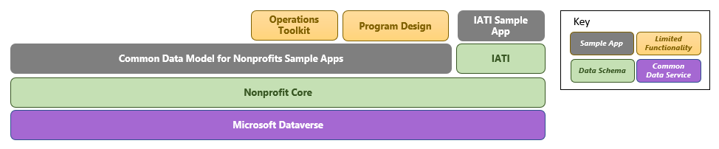

#### Upgrade Process

The upgrade to v2.3.3.0 decoupled the Sample Apps from the Core. Failing to follow the steps below will delete all sample apps. The new Sample Apps solution solely contains the Sample Apps. This solution must be created and installed first because when the new Core is upgraded it will delete the Sample Apps. The upgrade process is:

1. Install Sample App Base solution
2. Upgrade Core to current version
3. Upgrade Sample App solution to current version

#### New Installs of NFP Core

New installations of the Nonprofit Core no longer require the installation of the Sample Apps. In scenarios when they are not needed. If, however an organization plans to install any additional solutions beyond the Core (shown above) they must install the Core Sample Apps to provide the base dependencies required by Sample Apps in other solutions.

#### Removal of Sample Apps

To remove the sample apps in an upgrade scenario, install the core without install the sample app base solution and the sample apps will be removed.

# Import solutions to CDS

There are three different ways to install the Nonprofit Accelerator. Installs can be done using AppSource, manually, or using the admin tool package deployer.

* AppSource will provide you with the simplest install experience and will provide you with notifications of updates, and an integrated upgrade path.
* Manual installs are more involved and allow a level of control that may not be found in AppSource installs.
* Package deployer installs should only be executed by admins who have specific purpose in mind for using the package deployer. This install method is outlined in the Nonprofit Accelerator Admin Guide.

## Manual Install

1. Go to <https://github.com/microsoft/Industry-Accelerator-Nonprofit/>. Navigate to releases. Download **Common Data Model for Nonprofits Core** solutions.
2. Go to your organization’s Dynamics 365 Customer Engagement portal (e.g. <https://organizationid.crm.dynamics.com>).
3. Click the **Settings (Gear) button** and then **Advanced Settings**

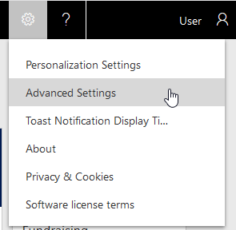

1. Click the arrow to the right of **Settings**

Settings

1. Click **Solutions**.

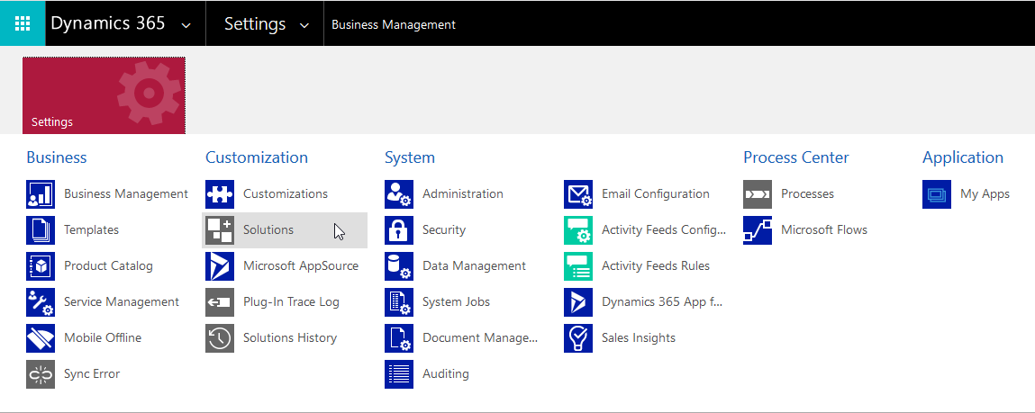

1. Click **Import**.

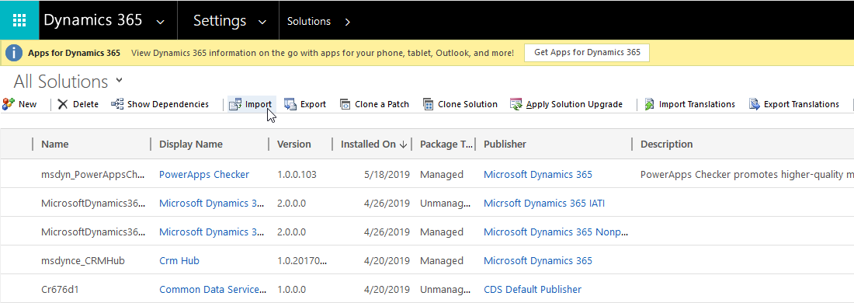

1. If this is a new install, browse to the **Common Data Model for Nonprofits Core** and then click **Next.** If this is an upgrade, you will want to follow the steps to upgrade the core.

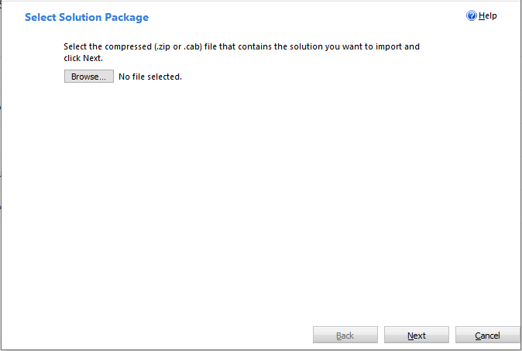

1. Click **Import.**

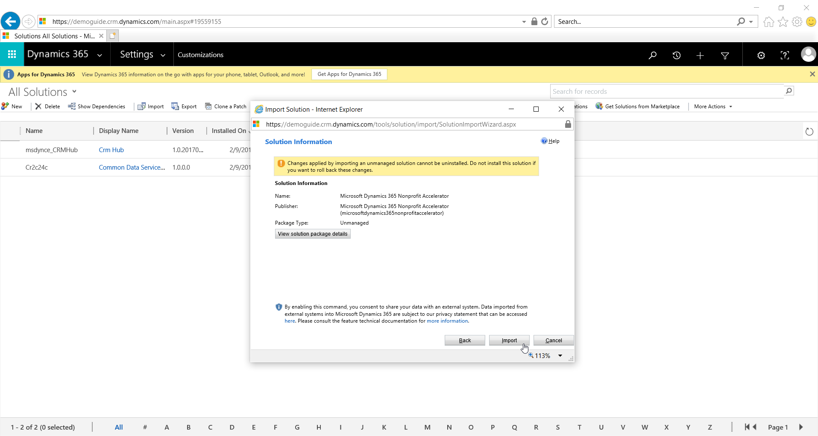

1. Wait until the process completes.

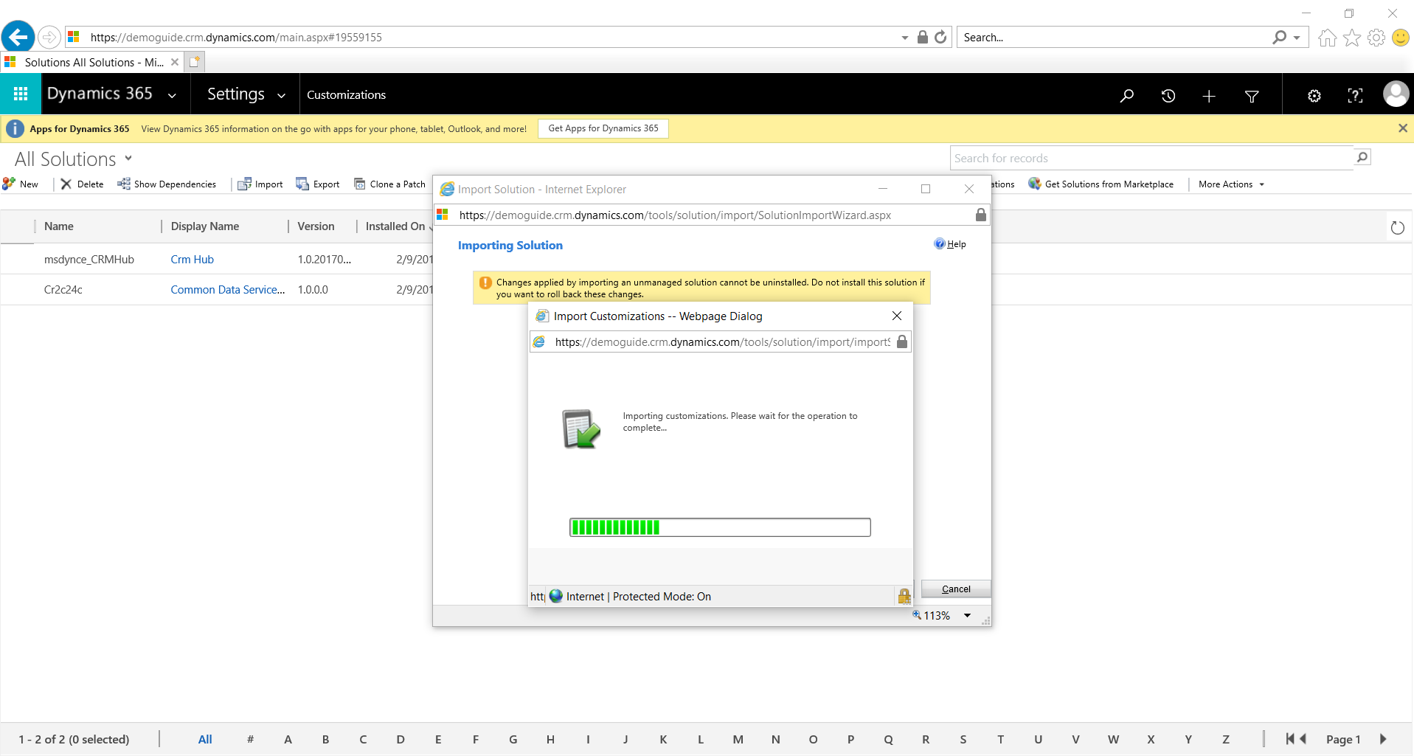

1. Click **Publish All Customizations**.

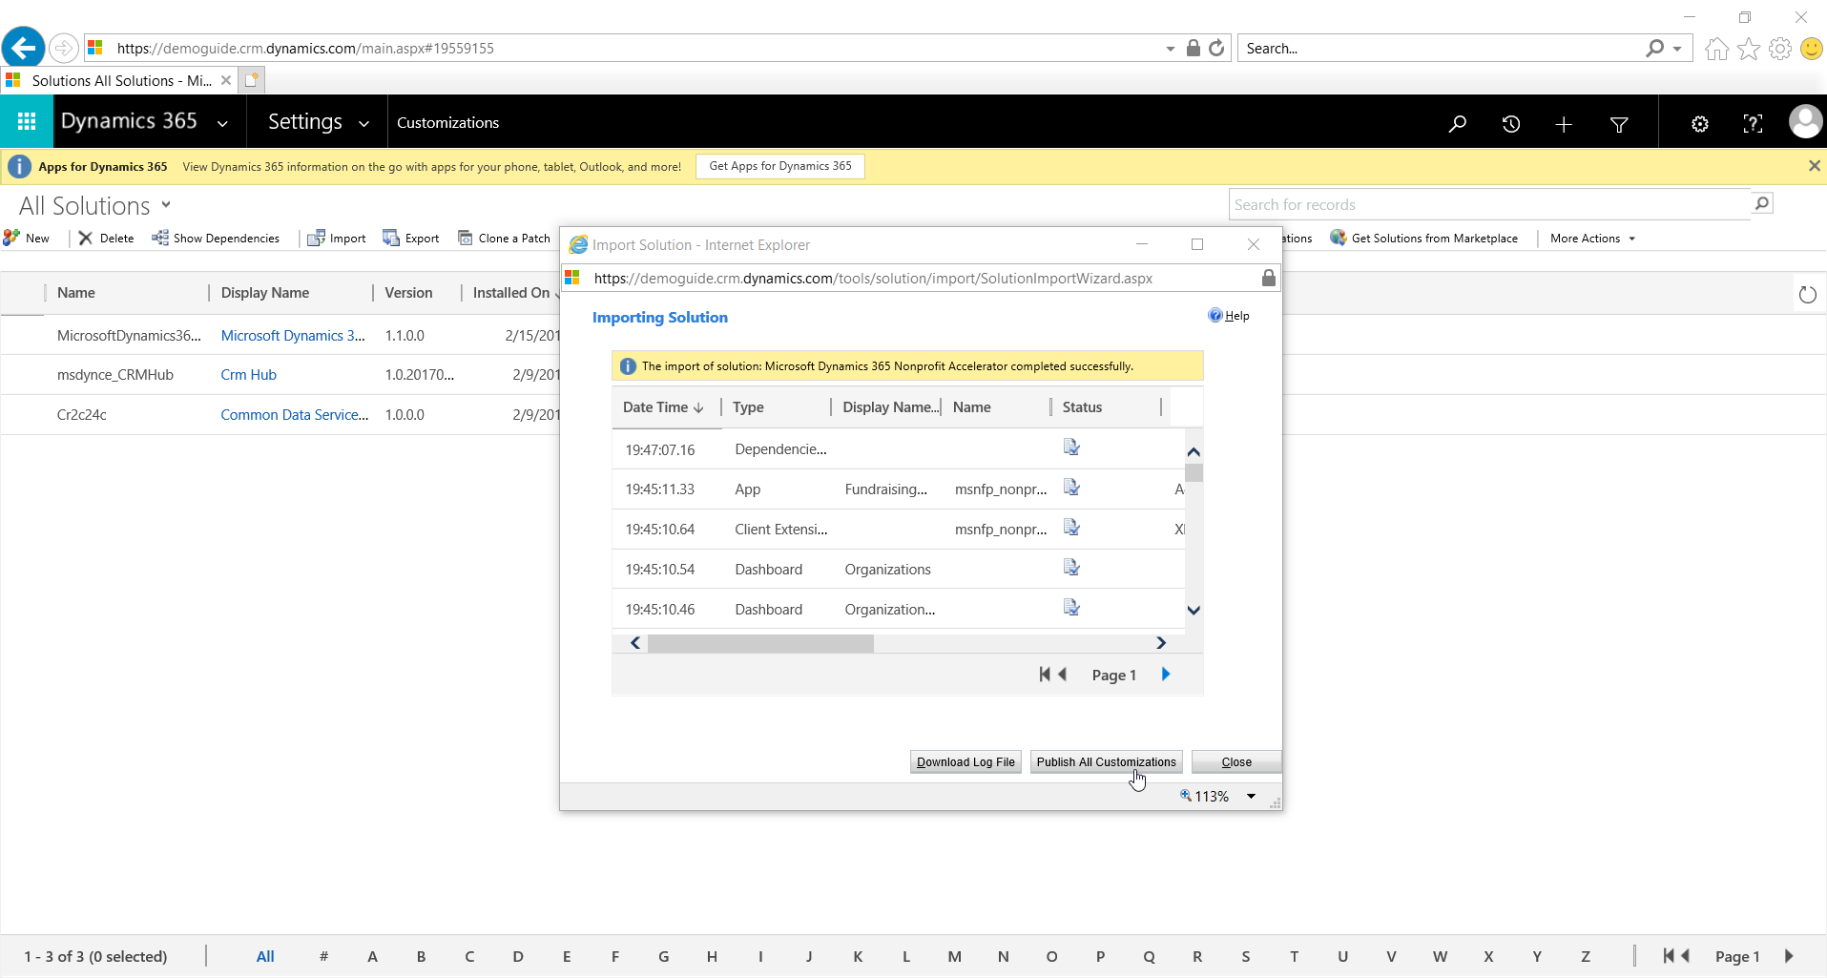

1. Optionally, repeat steps 6 to 10 for the **Common Data Model Nonprofit Sample Apps** if you want sample apps and any other solutions you want to install.

# Importing Sample Data

This explains how to import data to Dynamics 365 using the “Data Migration Utility”, which should be downloaded before starting the import process.

To download the tool, please refer to the following link: <https://www.nuget.org/packages/Microsoft.CrmSdk.XrmTooling.ConfigurationMigration.Wpf>

To run the tool, once downloaded, extract the files and double click on the application named “DataMigrationUtility.exe”.

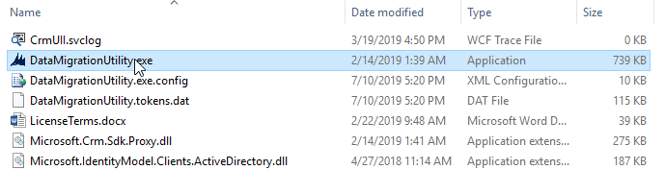

## Sample Data Packages to Import

The Microsoft Dynamics 365 Nonprofit Accelerator contains multiples solutions that could be use based on the customer needs. Each solution can be installed to provide more functionalities to the system. Next, we are providing a list of the solutions and the data package needed to test or review each solution functionalities.

#### Nonprofit Core Solution

The following packages should be imported in order for the Nonprofit Core Solution:

1. NonprofitAccelerator_NonprofitCore_DataPackage_3_0_3_0

#### IATI Solution

The following packages should be imported in order for the IATI Solution:

1. NonprofitAccelerator_MicrosoftDynamics365_IATI_DataPackage_3_0_3_0

## Step by step to import packages

The following steps explains how to install the sample data package for any solution:

1. Download and save the data package.
2. Open the “Data Migration Utility”, select “Import data” and press “Continue”.

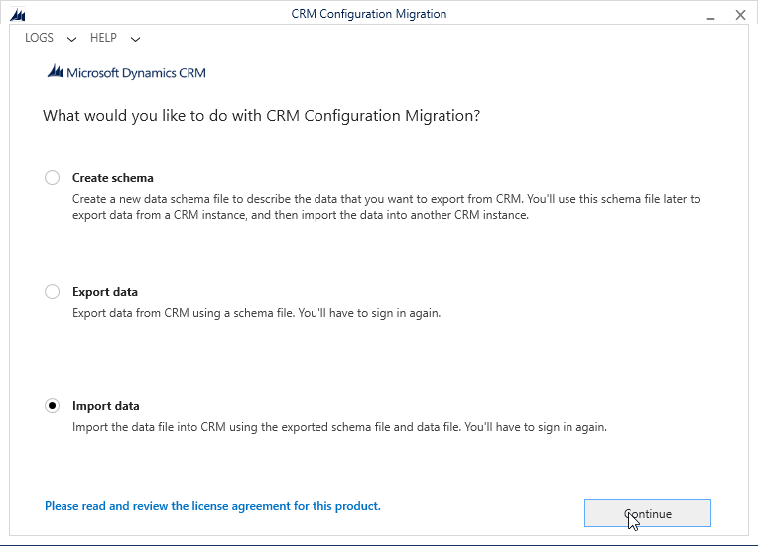

1. Provide the user and password for the environment that you want to import the data and press “Login”. Note that you may need to change the “Deployment Type” and “Online Region” based on the environment that you are using.

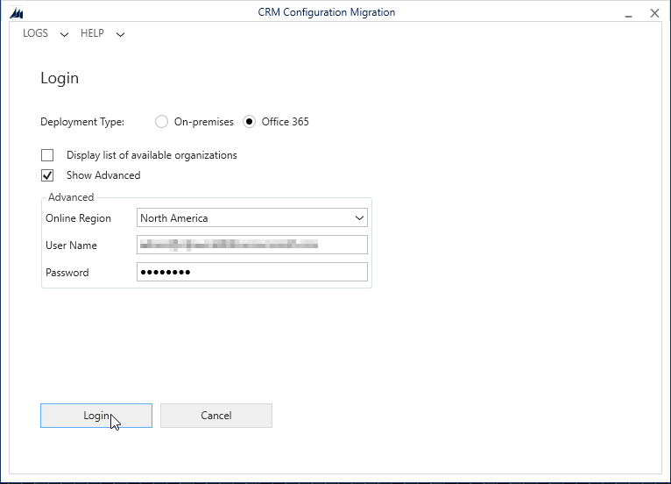

1. Once authenticated, click on the search button to search for the sample data package.

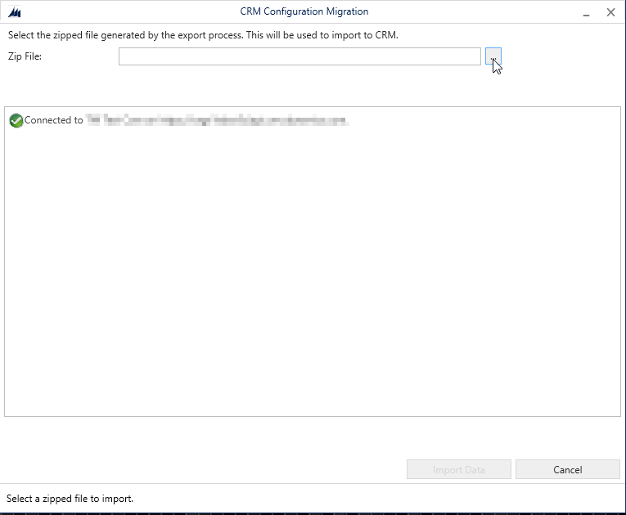

1. A search window will appear. Locate and select the previously downloaded data package and press “Import Data” to begin the import process.

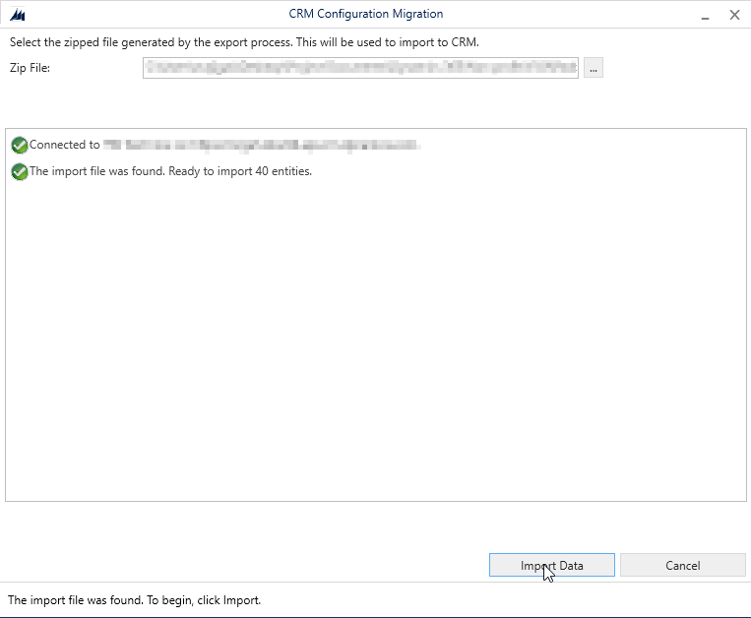

1. After the process is complete, a message will be display in the system notifying “The import to CRM is complete”.

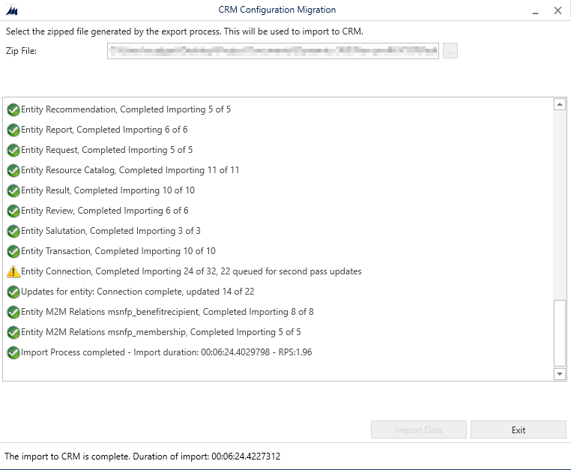

# Create Trial Environment

This section provides guidance on how to create a Dynamics 365 Environment with the Microsoft Nonprofit Accelerator.

## Create Dynamics 365 Company

1. Access this website from <https://trials.dynamics.com/>

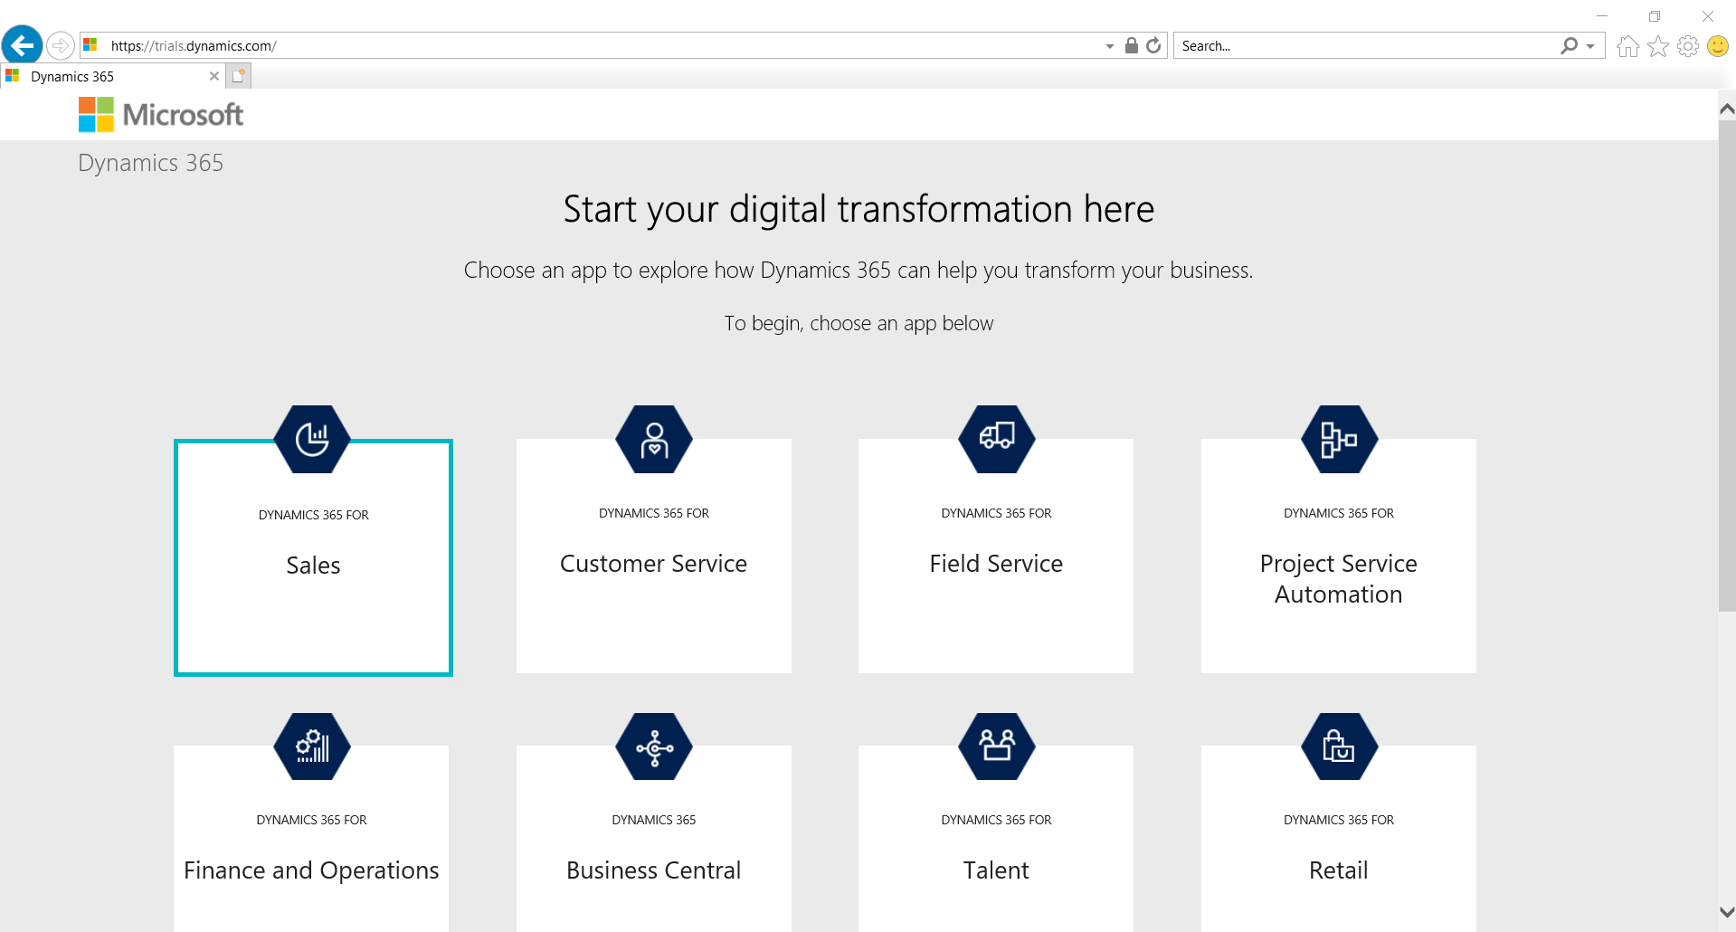

1. Scroll down to the end of the page and click **Sign up here**.

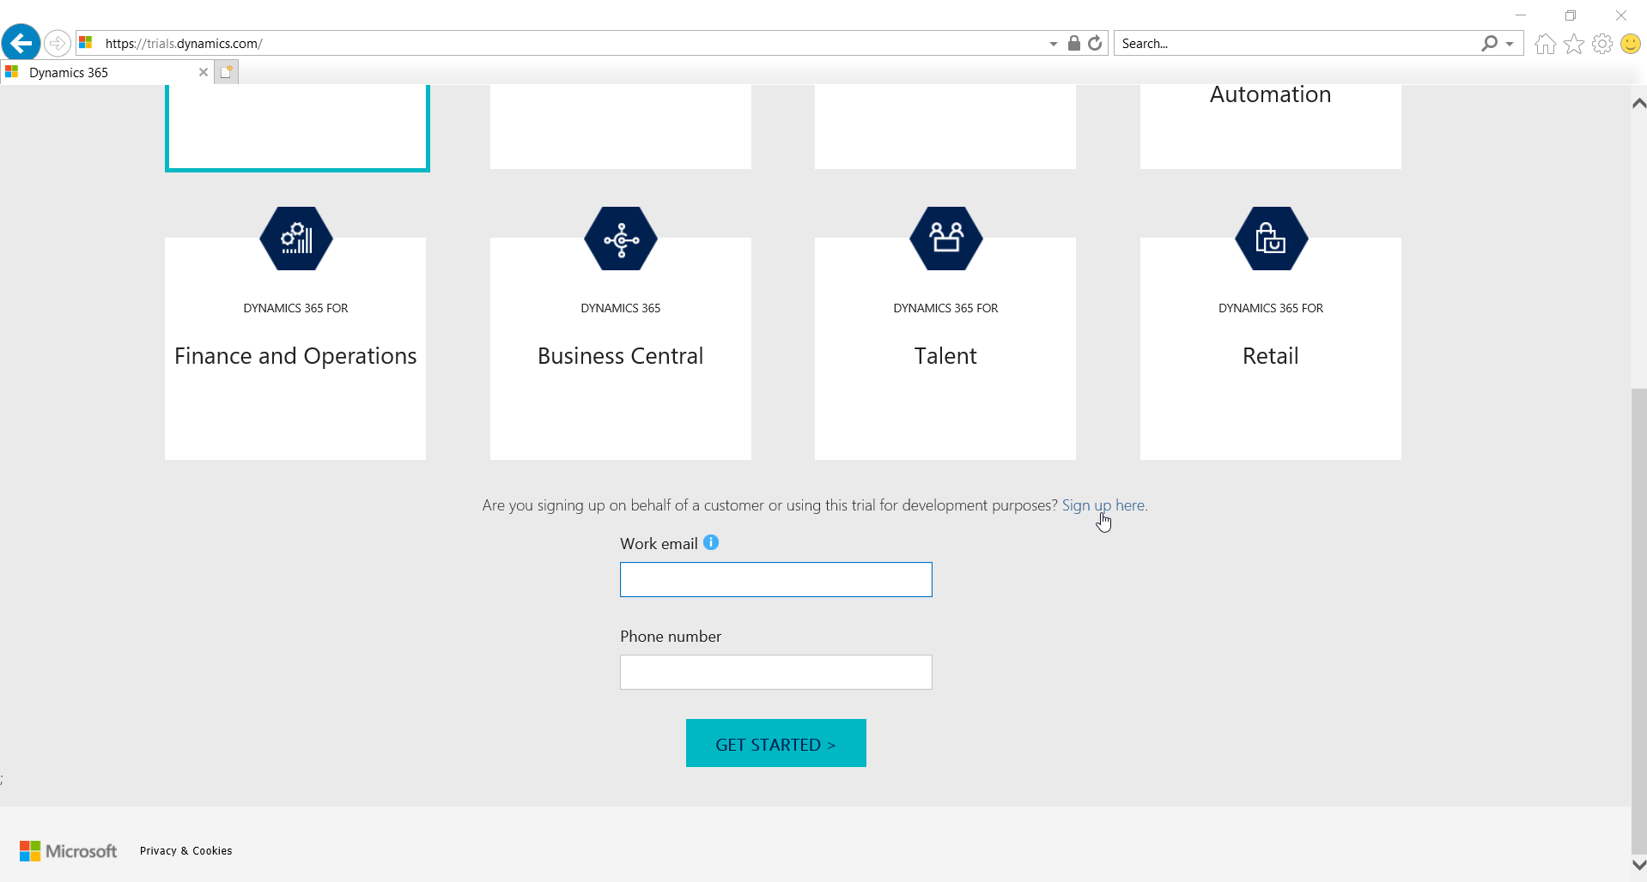

1. Click **No, continue signing up.**

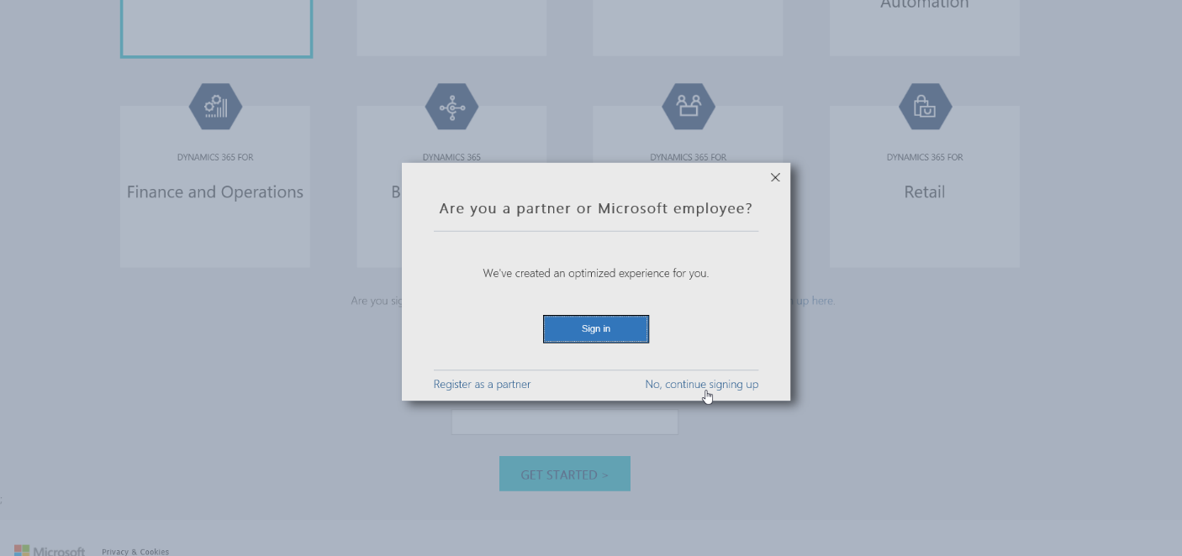

1. Complete all fields and click **Next**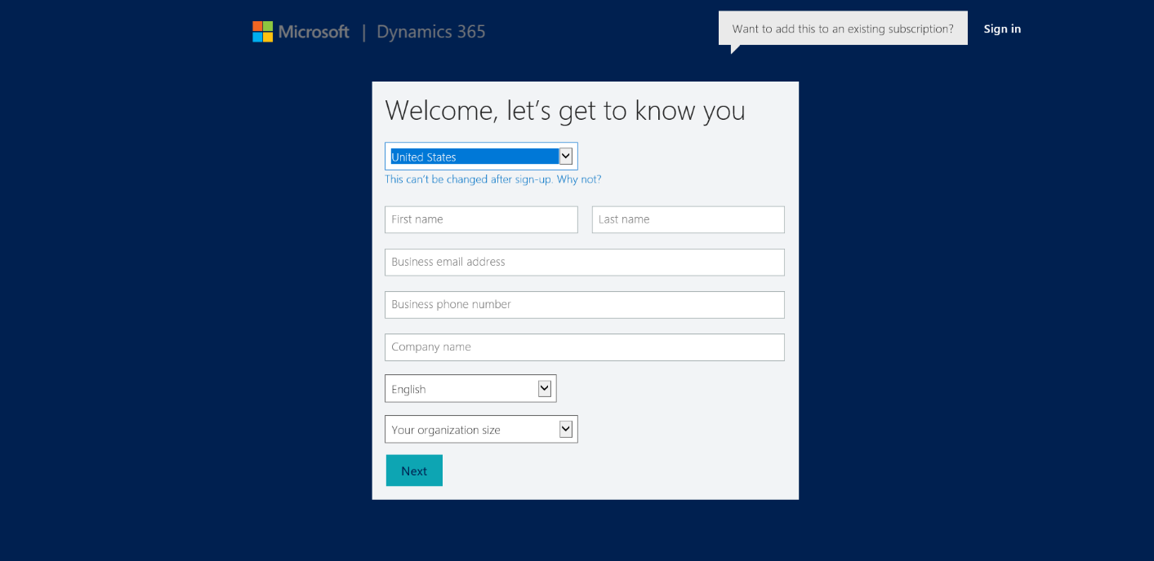
2. Complete the fields to create a new ID and password to sign in and then click **Create my account**.

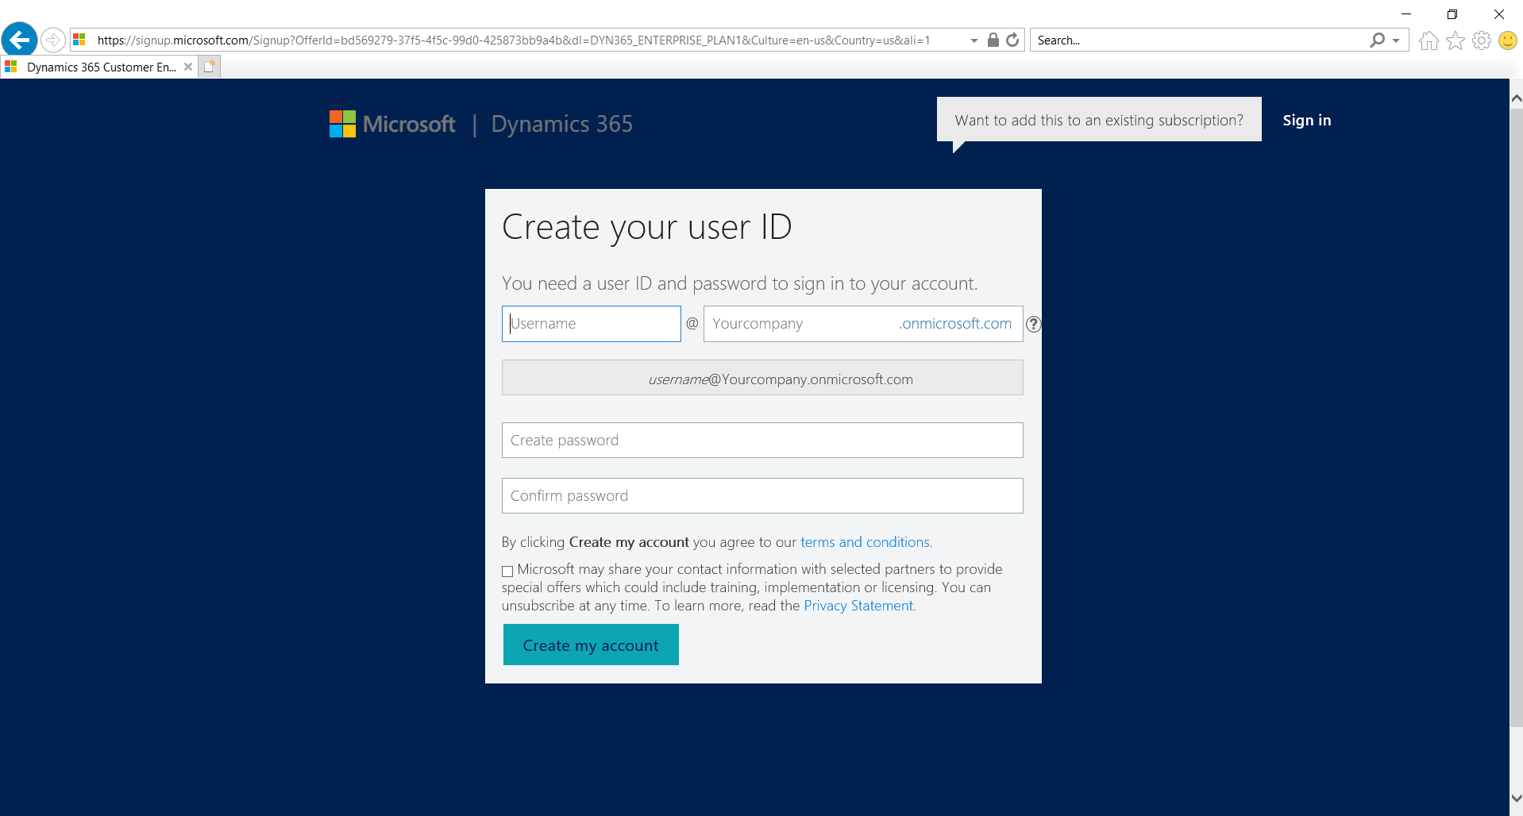

1. When finished, click **Set up**.

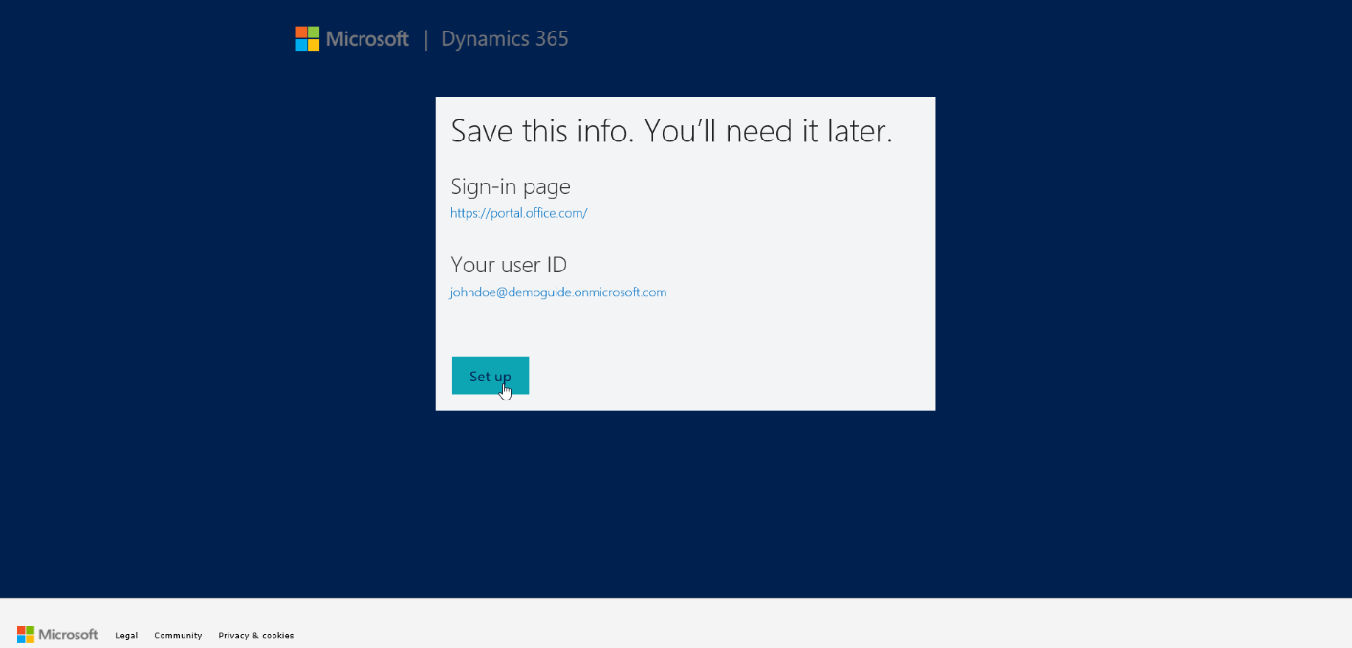

1. Select the “**None of these. Don’t customize my organization”** check box and click **Complete Setup**.

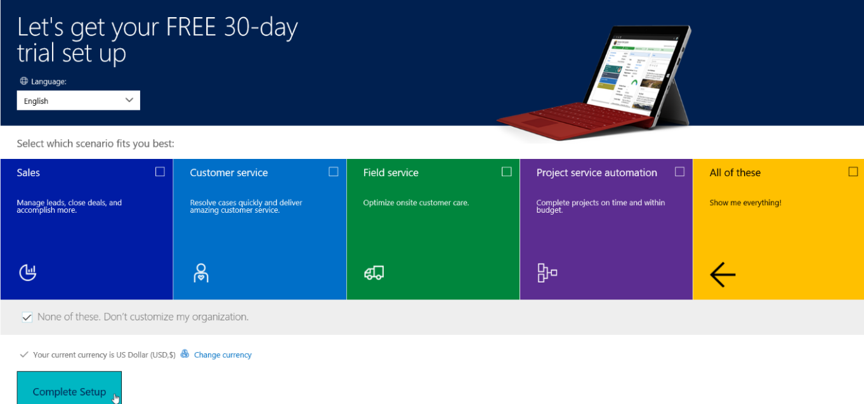

1. Wait until the page loads to Dynamics 365. If the page fails to load or you receive an error message navigate to youcompanyname.crm.dynamics.com. (where “yourcompanyname” is replaced with the company name you entered previously)

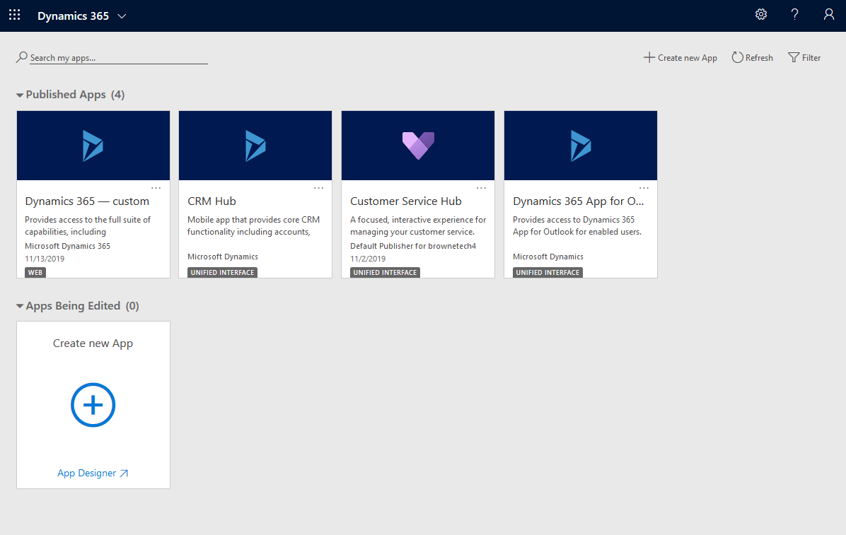

## Import solution to Dynamics 365

Access the Dynamics 365 Packages from <https://github.com/microsoft/Industry-Accelerator-Nonprofit/releases>.

1. Download the latest release version solution.

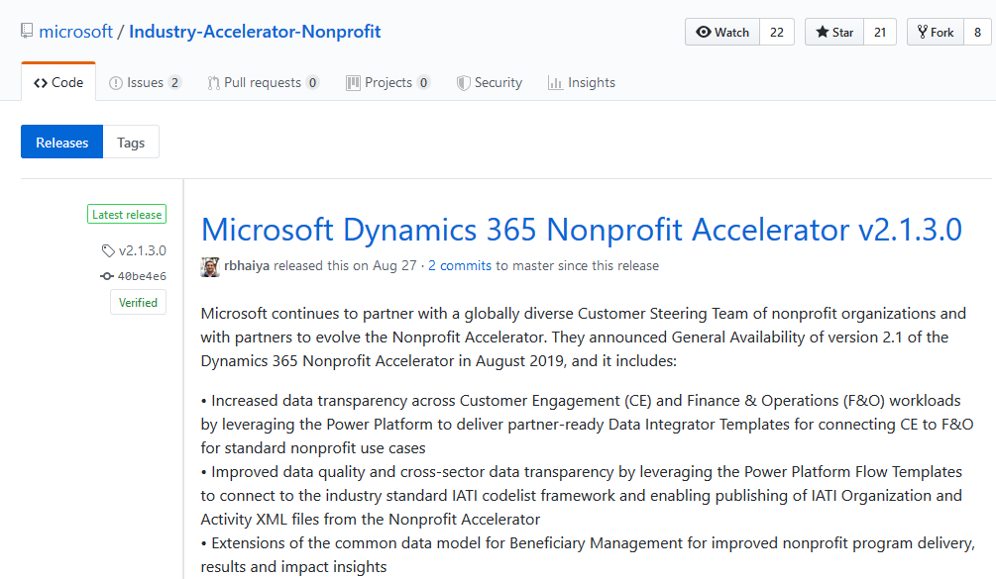

1. In the top right, click the **Gear**

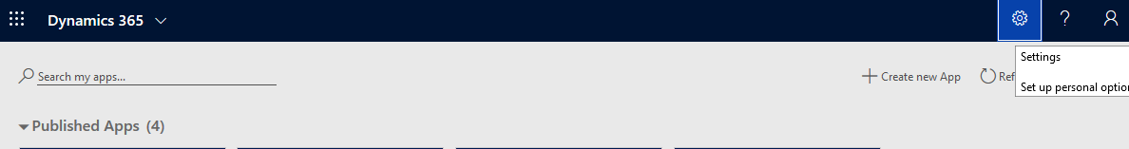

1. Click **Advanced Settings**

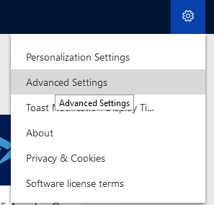

1. Click **Settings** > **Solutions**

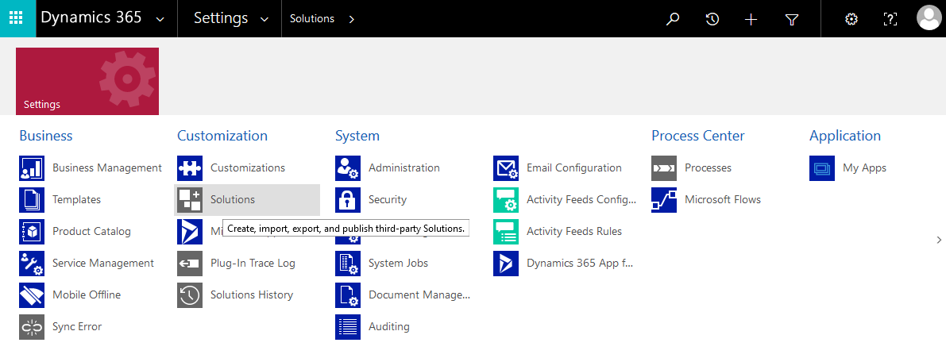

1. Click **Import**.

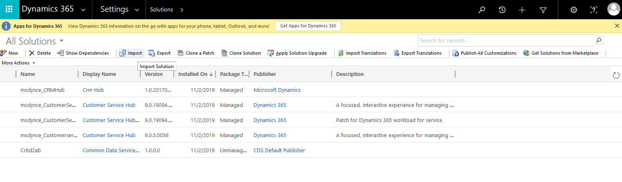

1. Click **Browse** and navigate to and select the solution that you downloaded and Click **Next.**

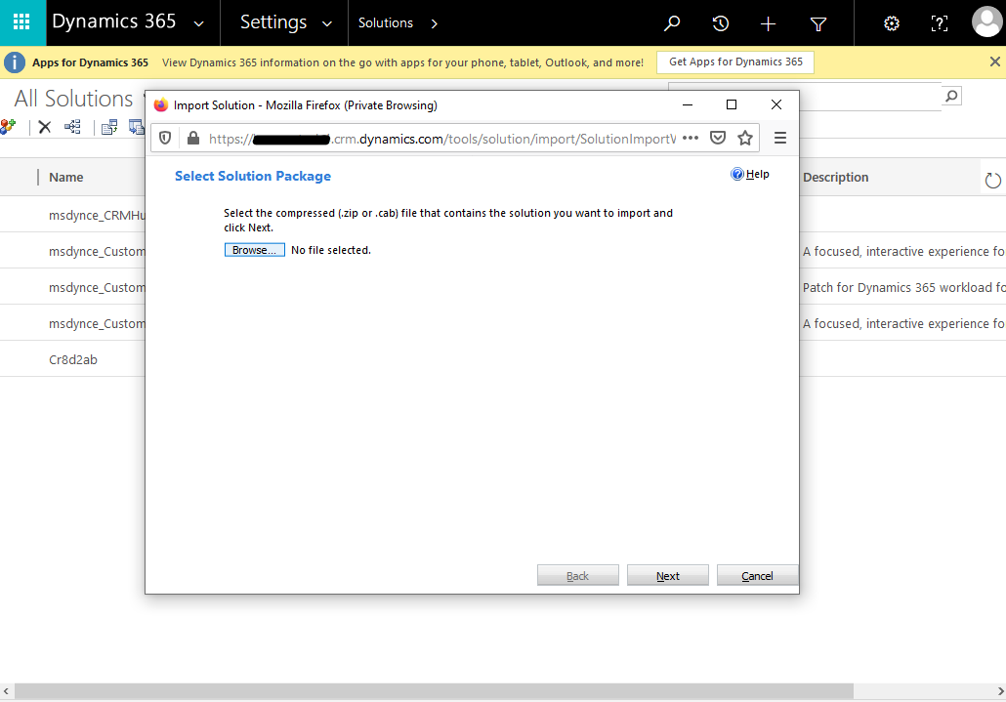

1. Click **Import.**

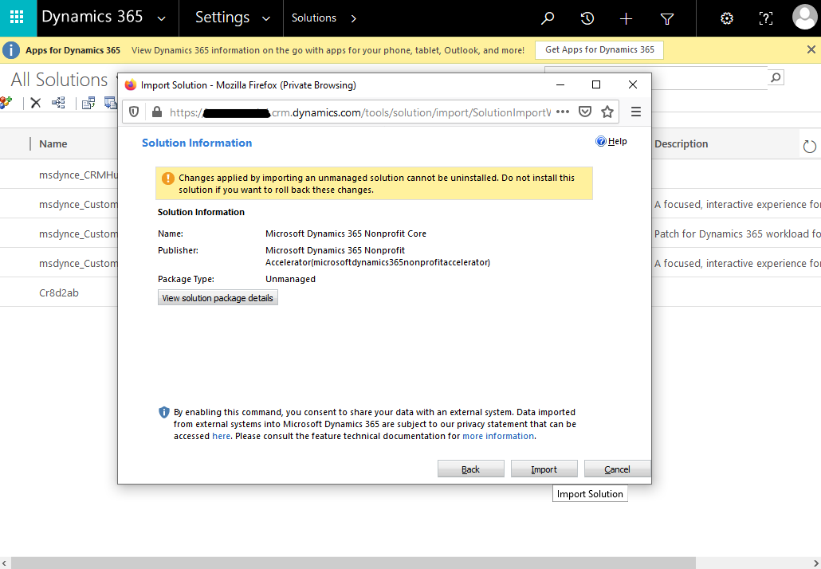

1. Wait until the process completes.

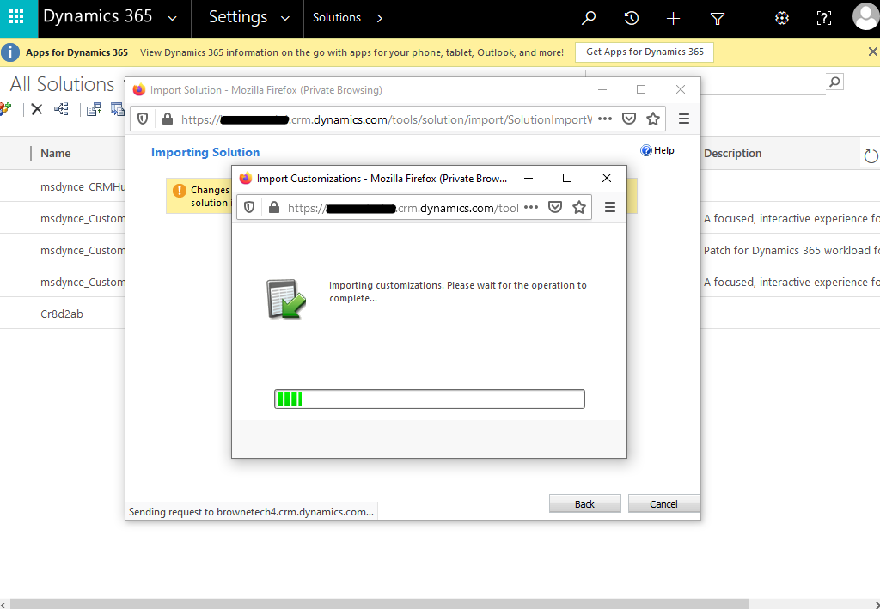

1. Click **Publish All Customizations** when it completes click **Close**

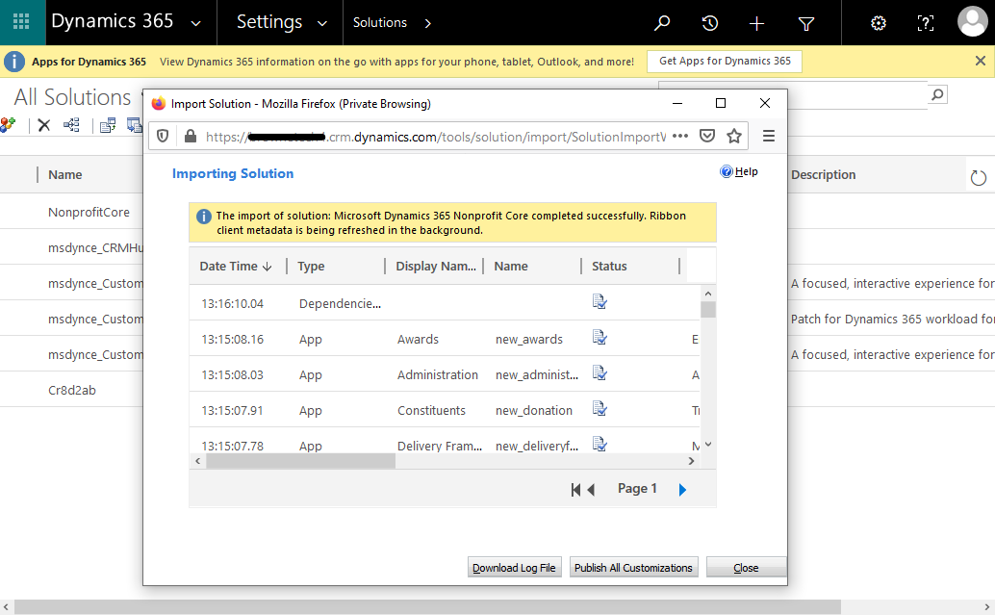

1. Click **Publish All Customizations**.

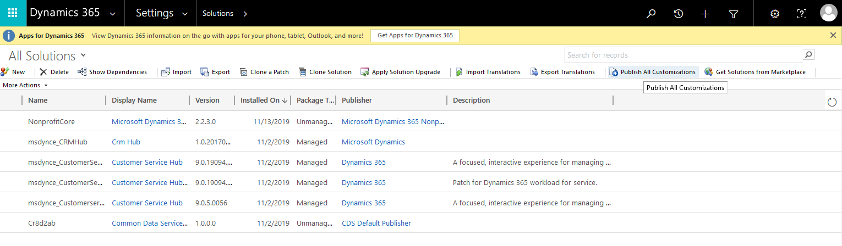

1. **Refresh the page** and click the **>** by **Dynamics 365**.The imported solution should appear in Dynamics 365.

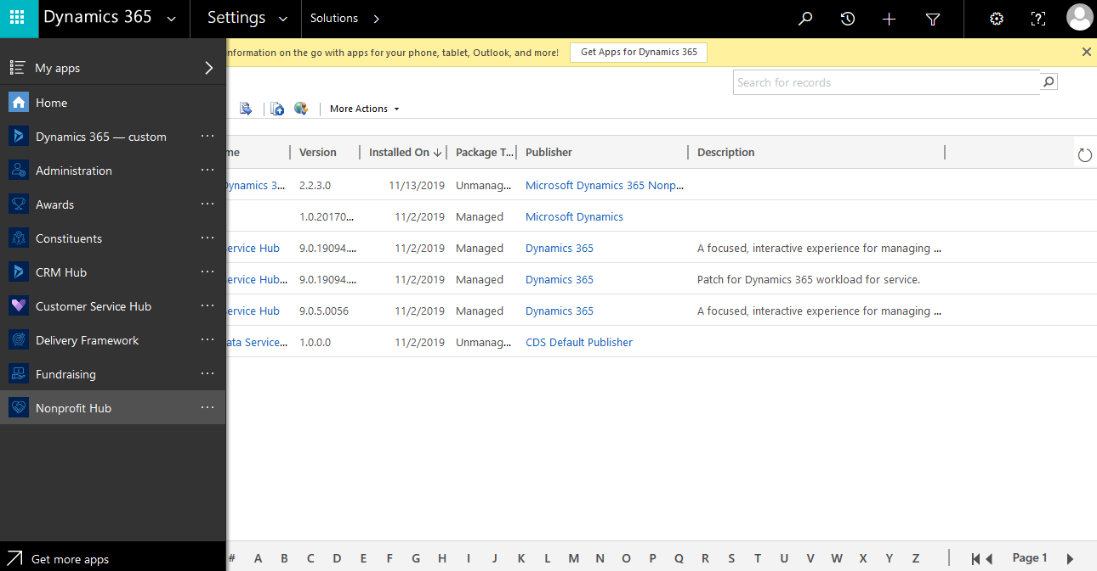

## Create new user in Dynamics 365

1. Click **Admin** located under the Menu

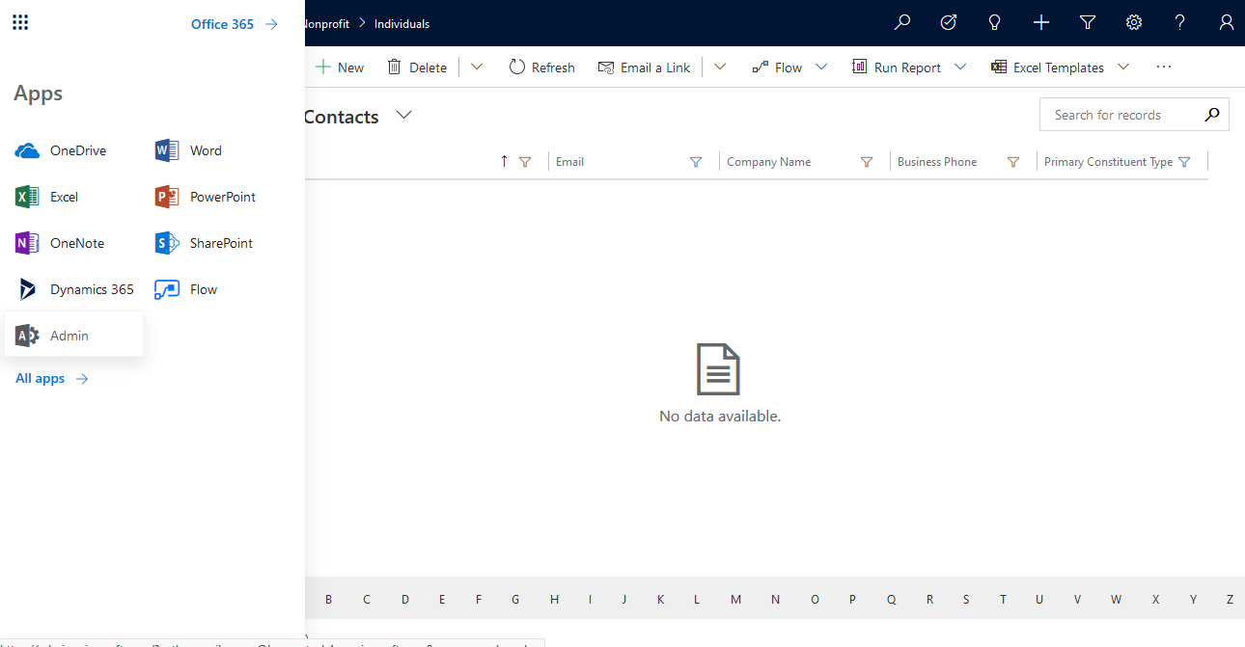

1. Click **Add a user.**

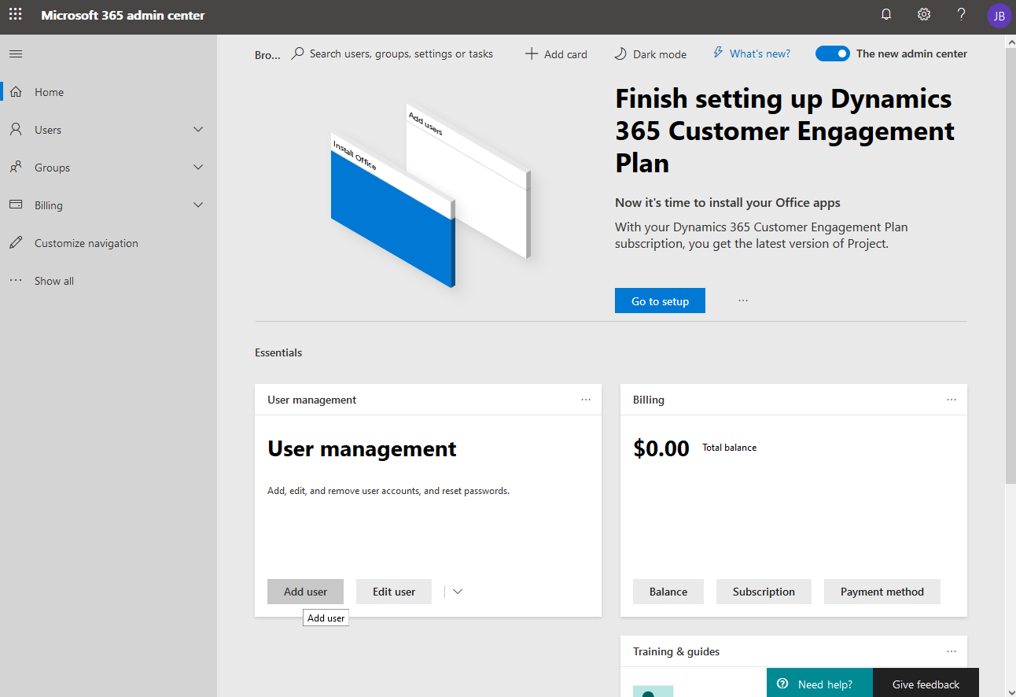

1. Complete the user information and click **Next**.

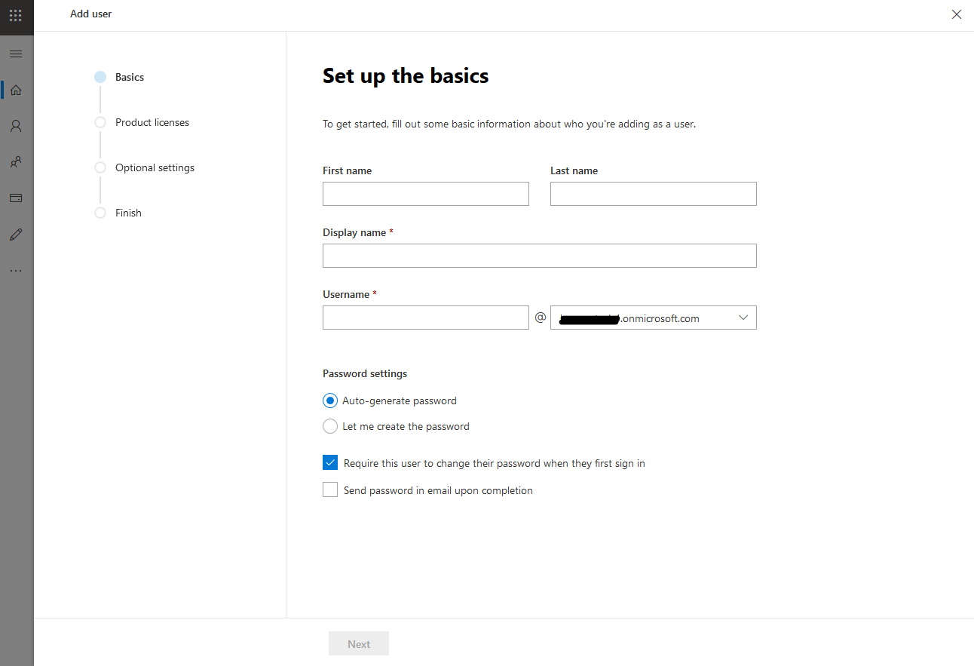

1. Under Licenses add a **Dynamics** license and click **Next**
2. Click **Next**, then click **Finish adding**, then click **Close**

# Common Data Model Folder Setup Instructions

## Prerequisites

1. An Active Azure Subscription.
2. A preconfigured and valid CDM model.json file.
3. A Power BI Subscription.

## Create Azure Data Lake Storage Gen2 Storage Account

There are multiple ways to setup an Azure Data Lake Storage Gen2. The instructions below focus on performing these steps manually through the Azure Portal.

1. Login to your Azure Portal at [https://portal.azure.com.](https://portal.azure.com/)
2. Before continuing, ensure that you are logged into the same tenant as the Power BI Subscription that will consume this data.
3. Navigate to Resource Groups.

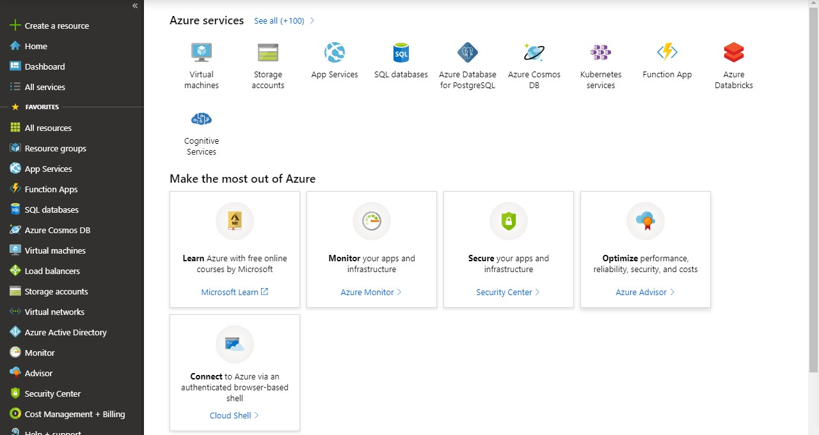

1. Open the Resource Group that the Azure Data Lake Storage Gen2 will be provisioned within. A new Resource Group can also be created for this step if needed or preferred.

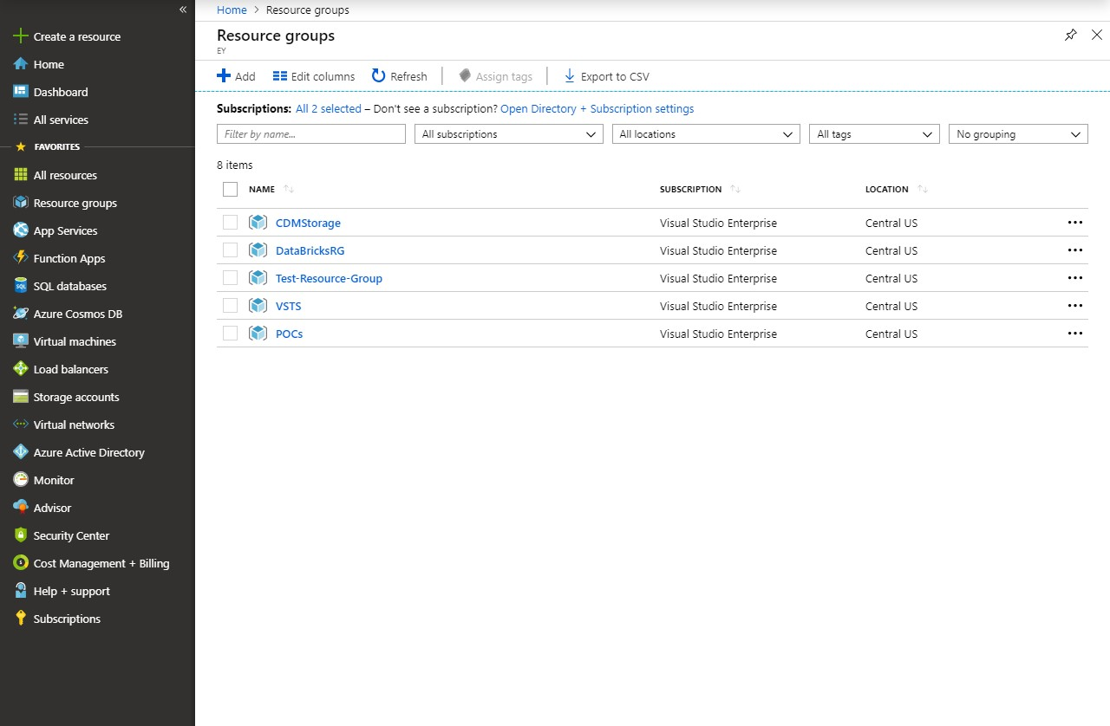

1. Inside the Resource Group, press the Add button to create a new Resource.

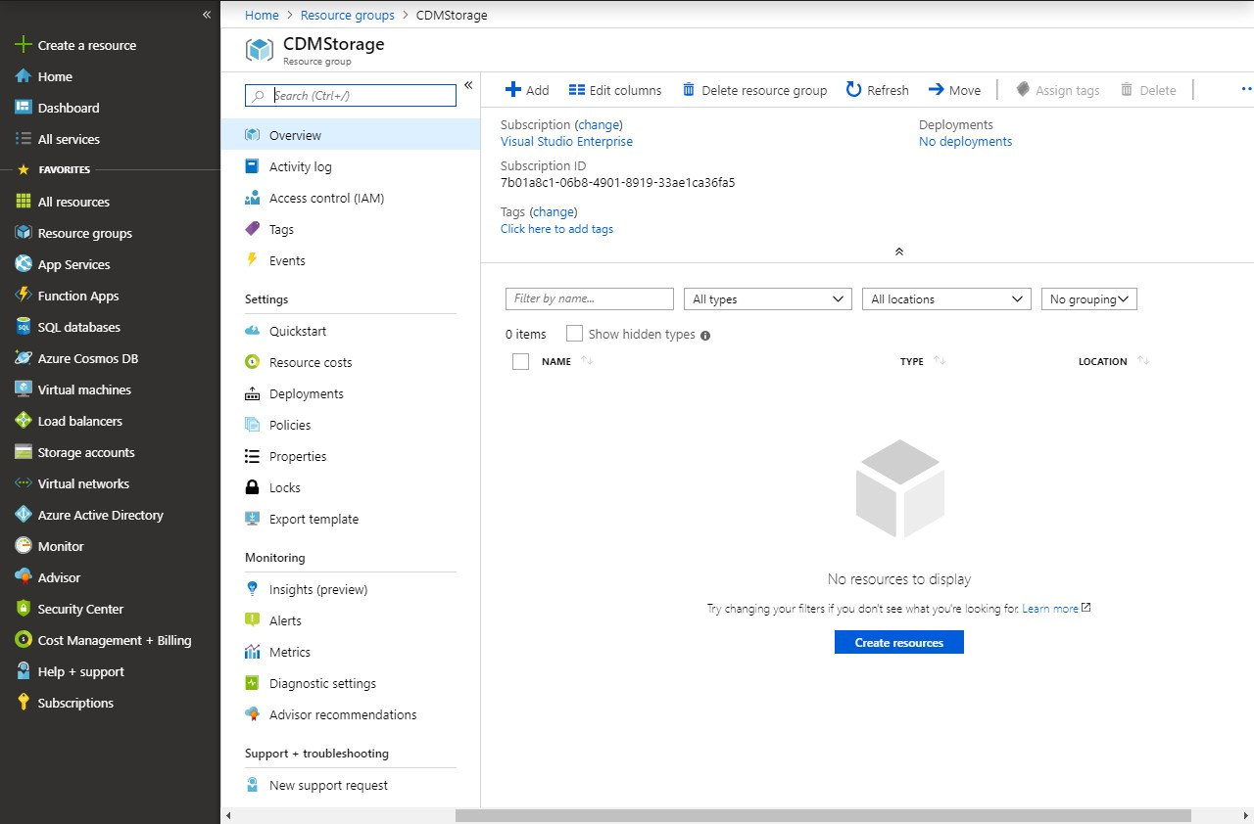

1. In the Get Started window, search for and select Storage Account.

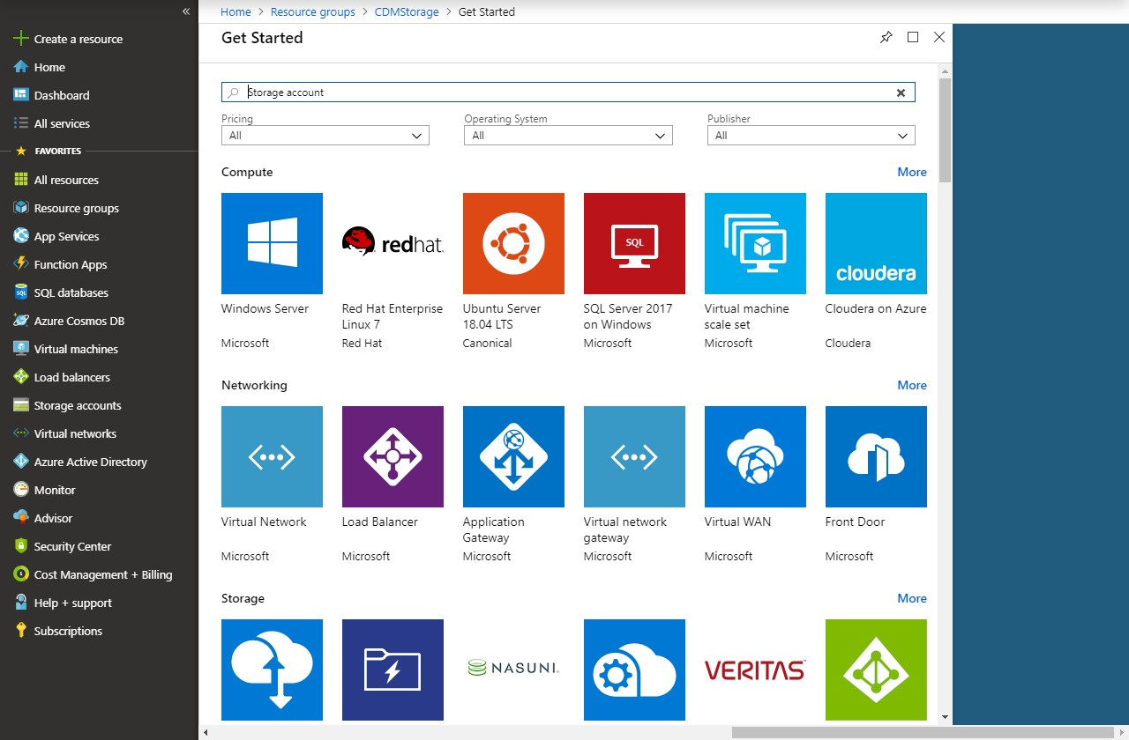

1. Press Create on the Storage account page.

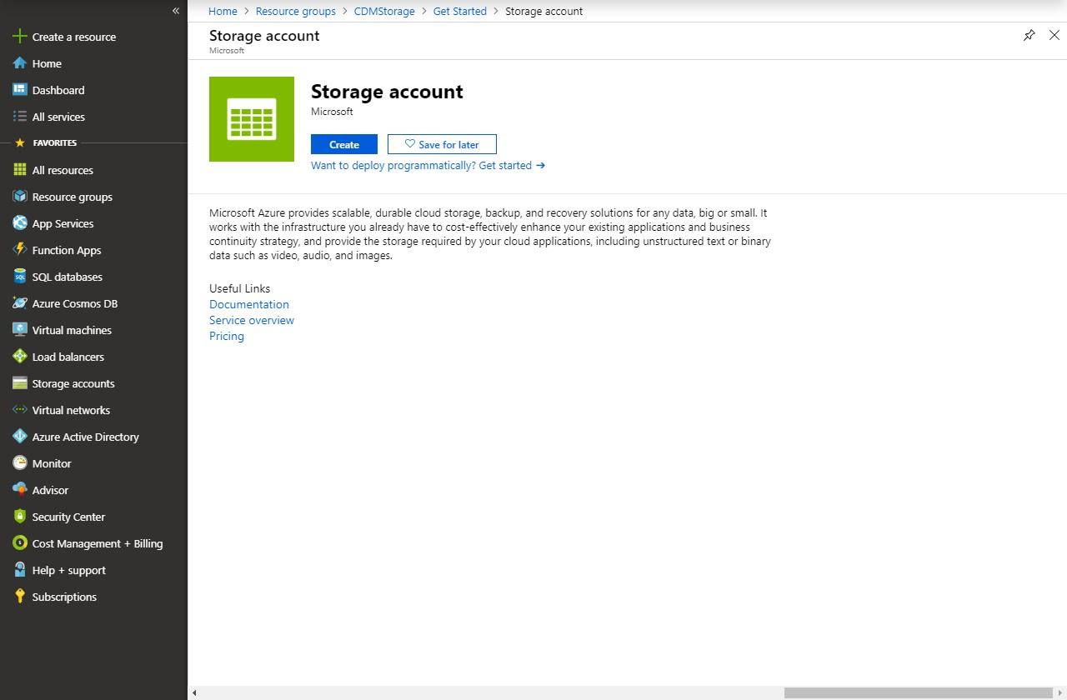

1. Ensure the following information is selected on the first Basics tab in the Create storage account screen.
   1. **Name:** You’re preferred name of the Storage Account.
   2. **Location**: This should match the location of your Power BI tenant. Instructions are provided below for finding this information.
   3. **Account Kind:** Storage V2 (general purpose v2)
   4. The default values for Performance and Access tier (default) can be used or changed.
   5. It is recommended that Replication be set to Read-access geo-redundant storage (RAGRS).

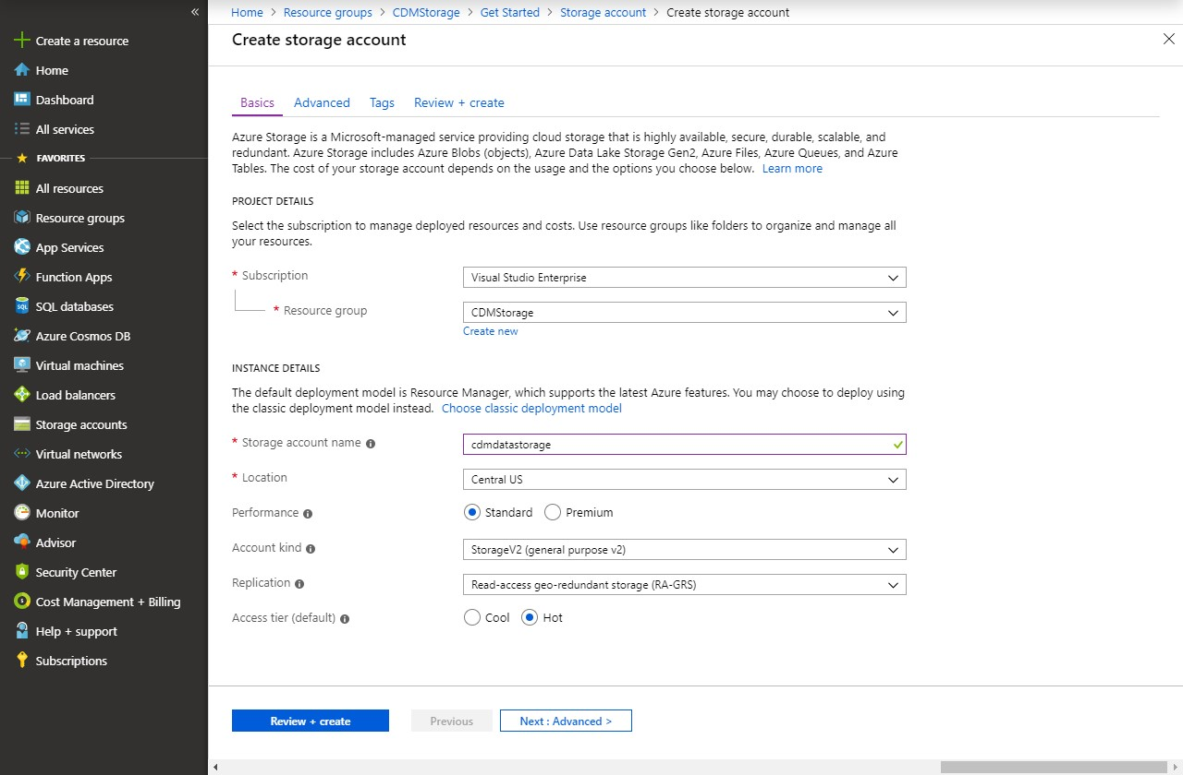

1. Press Next: Advanced >to navigate to the next screen.
2. On the Advanced tab, ensure that Hierarchical namespace is enabled.

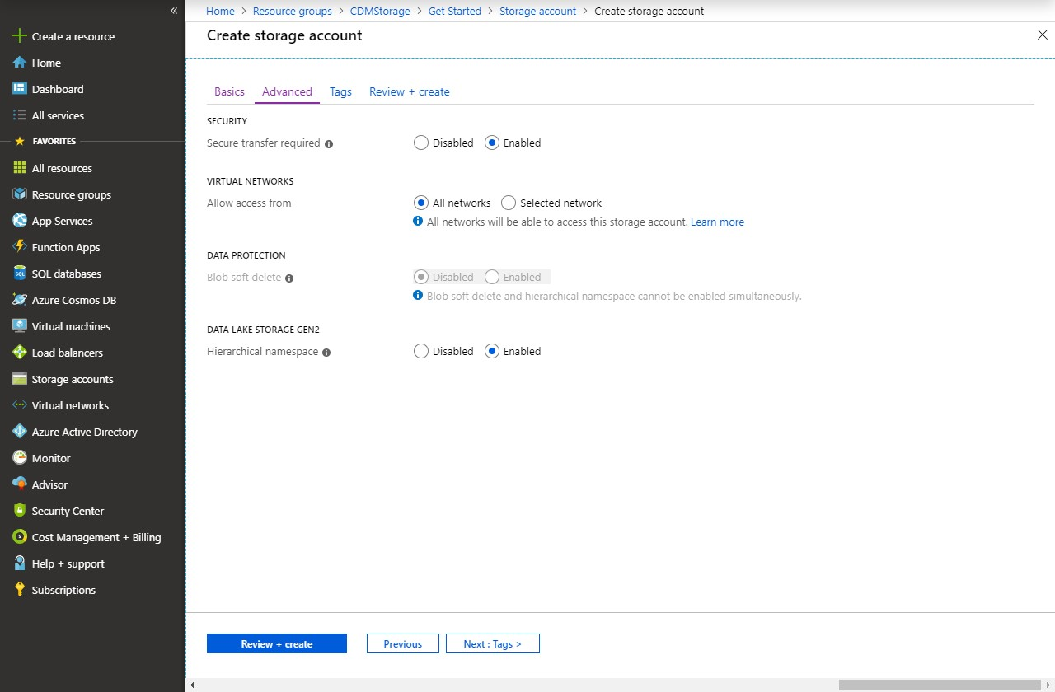

1. Press Review + Create.
2. Press Create to create your Storage account after validation finishes.

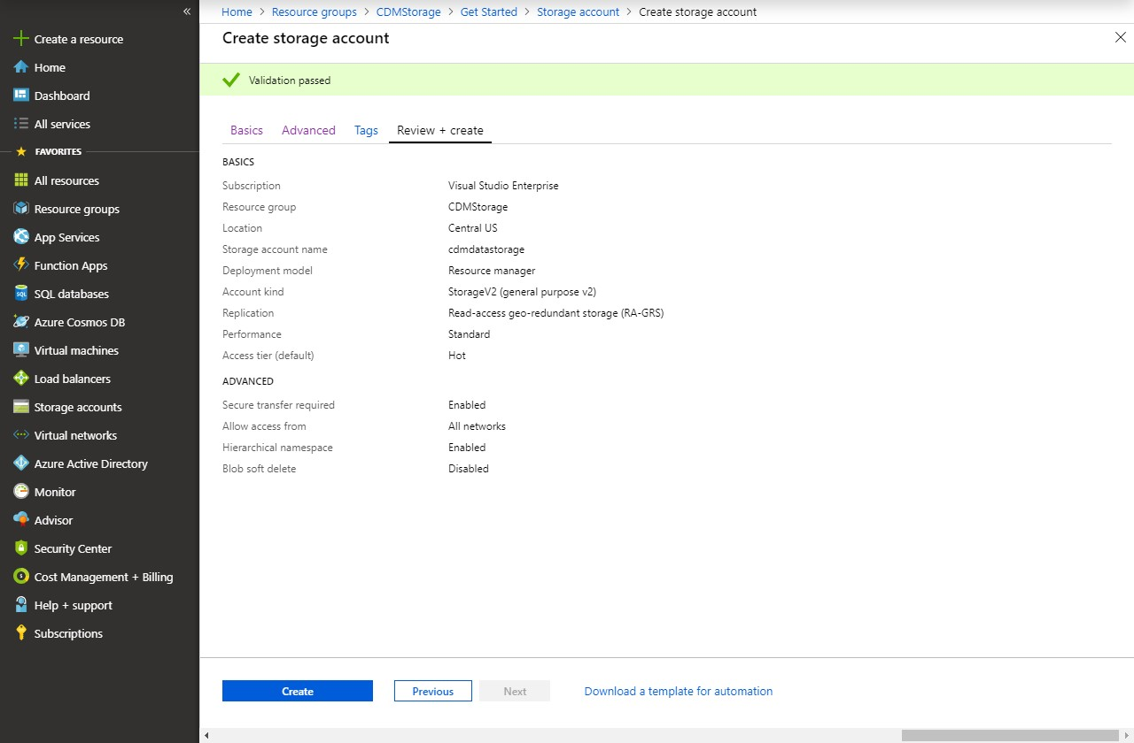

1. After some time, your Azure Storage Account will be created.

## Grant the Power BI Service a Reader Role

1. Open the Storage account created in the previous step. The simplest location to find it is within its Resource Group.

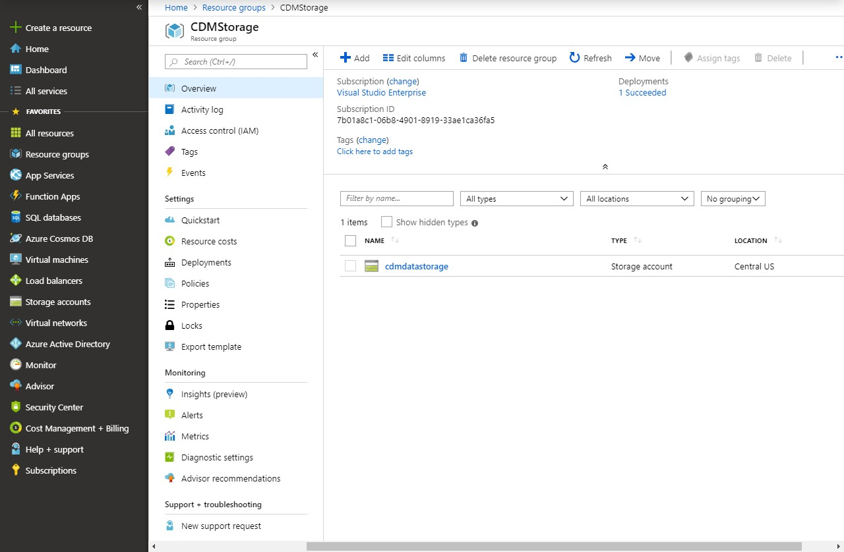

1. Inside the Storage account, click Access control (IAM).
2. Inside the Access control (IAM) pane, click the Role assignments tab.

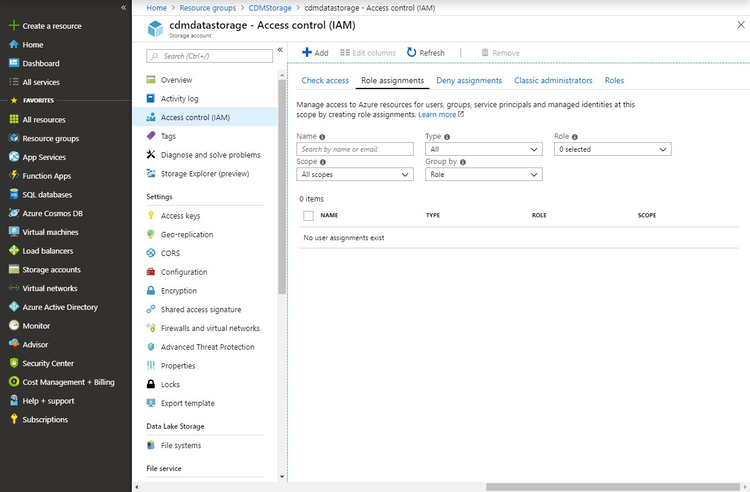

1. Click Add and then click Add role assignment.

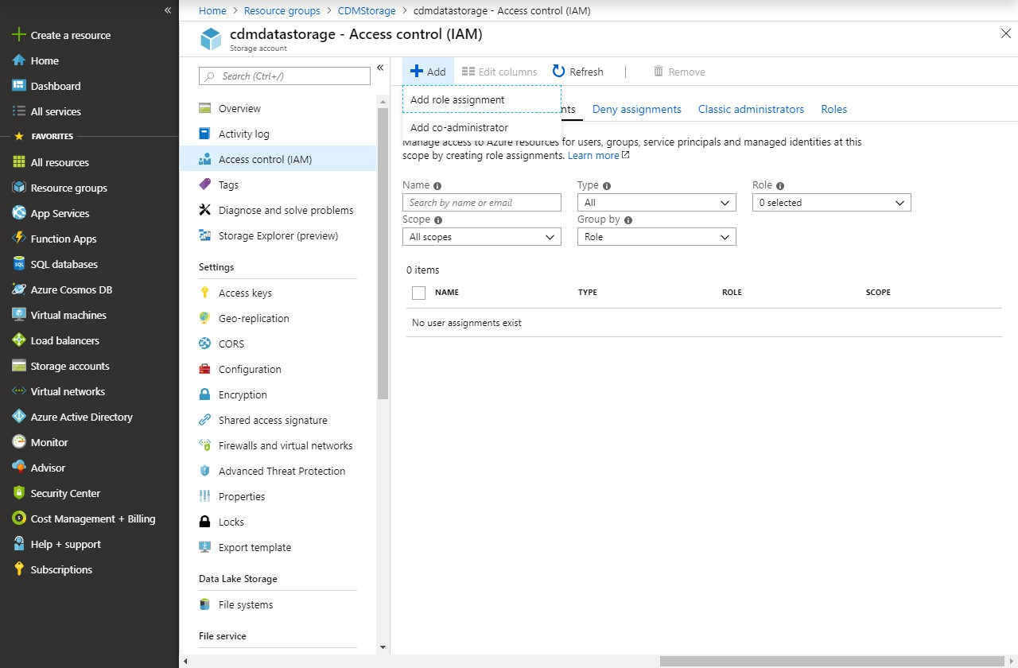

1. In the Add Role assignment pane:
   1. Select Reader within the Role dropdown.
   2. Search for Power BI Service in the Select textbox.
   3. Click on Power BI Service.
   4. Press Save.

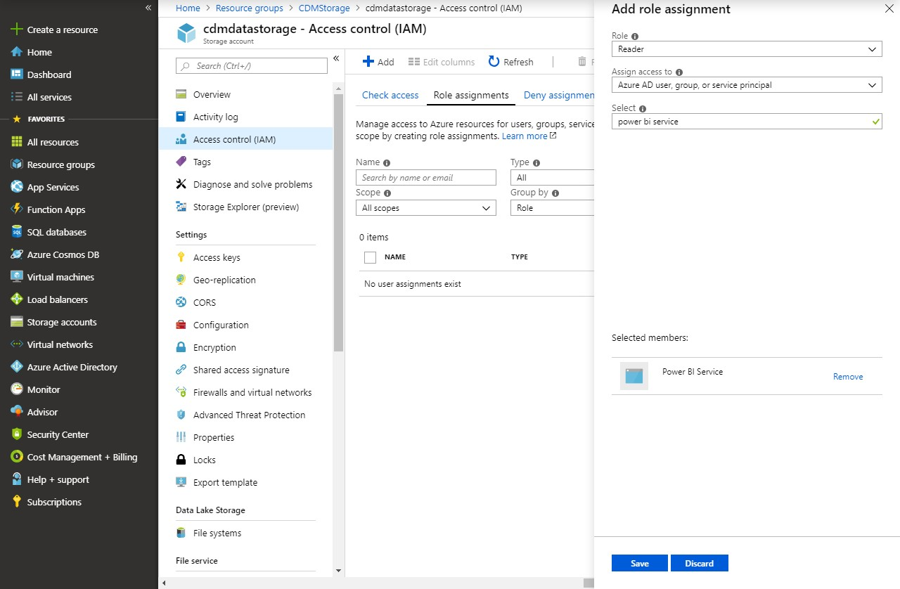

1. The Power BI Service will now have access to this Storage account, but Power BI may take 30 minutes to reflect these changes. This will not affect subsequent sections.

## Identify Power BI Service Ids

1. Login to [https://portal.azure.com.](https://portal.azure.com/)
2. Navigate to Azure Active Directory.

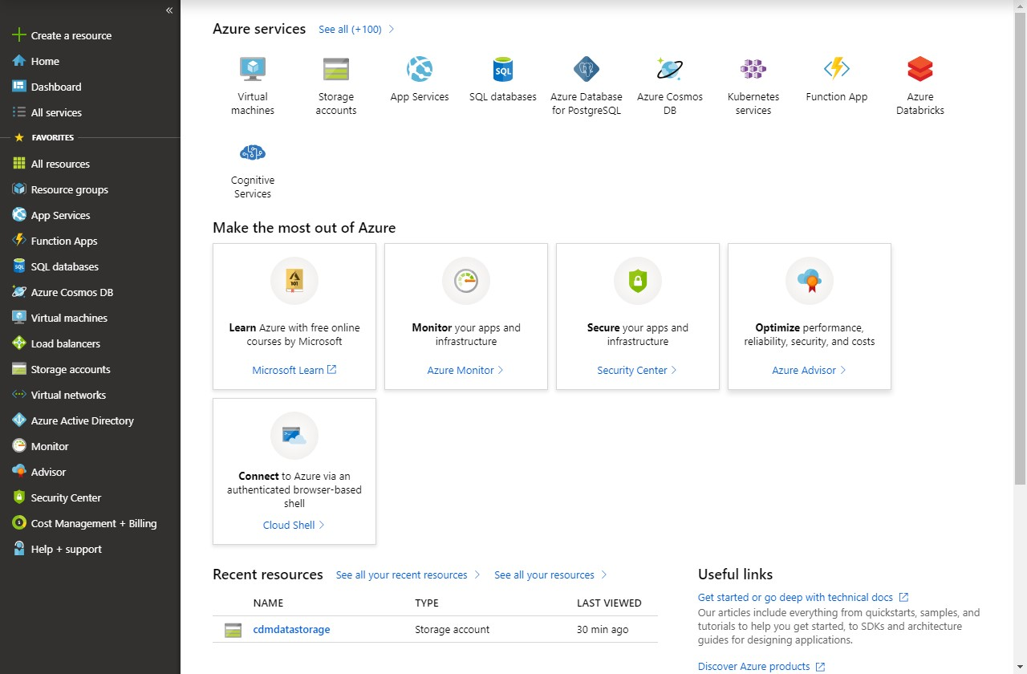

1. Within Azure Active Directory, select Enterprise applications.
2. In the All Applications window, change Application Type to All Applications and press Apply.

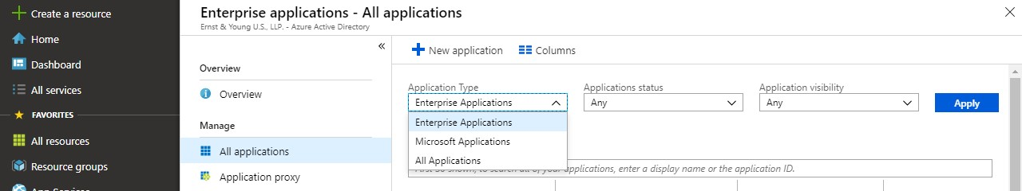

1. In the textbox in the All Applications page, type in Power.
2. Save the Names and Object ids for the following Applications for use in the next section: a. Power BI Service
   1. Power BI Premium
   2. Power Query Online

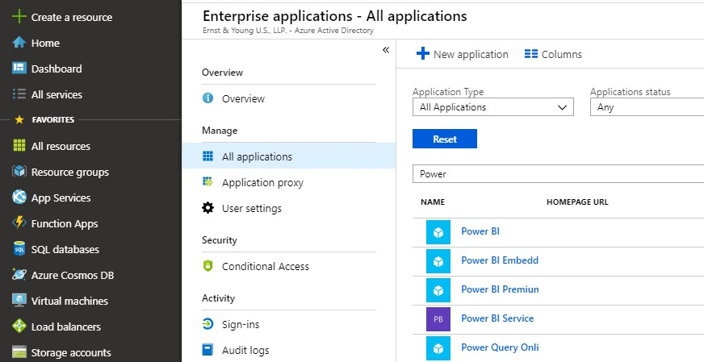

## Create a file system for the CDM data

### Initial Setup

1. Install Azure Storage Explorer from this link: [https://azure.microsoft.com/enus/features/storage-explorer/](https://azure.microsoft.com/en-us/features/storage-explorer/)
2. Open Azure Storage Explorer after it installs.
3. Click Add an account… and login using the same account you use to access your Azure tenant.

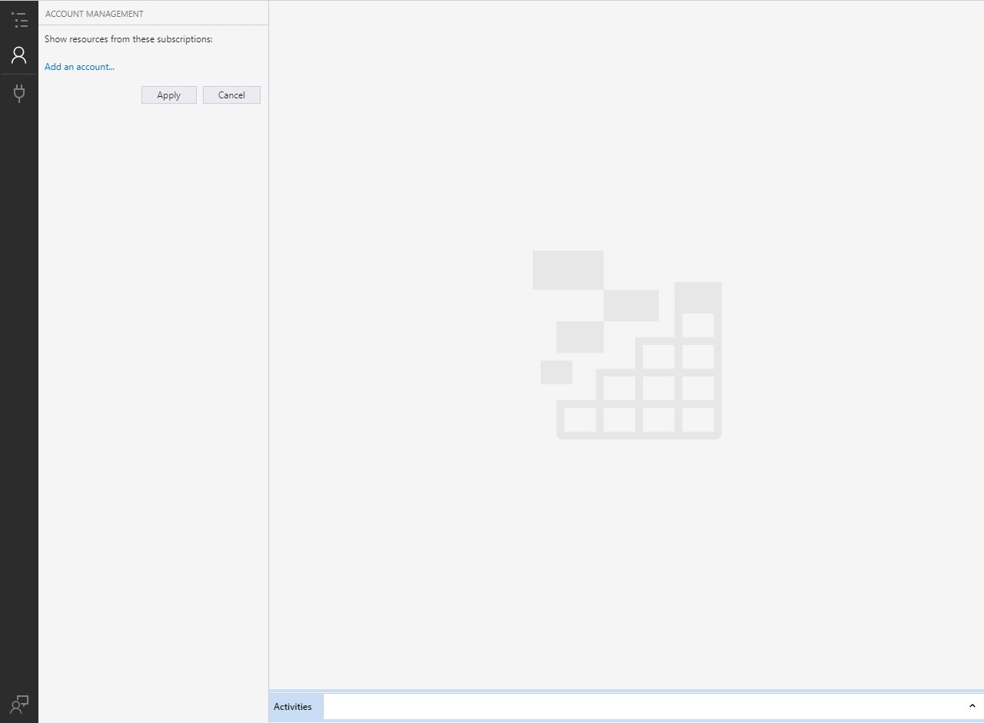

1. Expand your Storage Account within Azure Storage Explorer so that Blob Containers is visible.

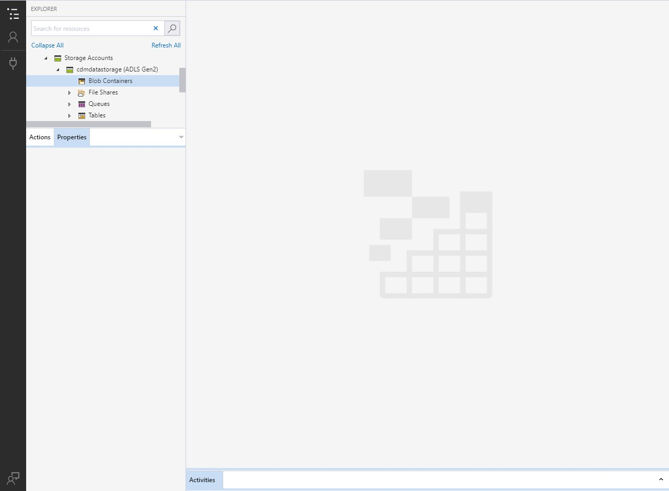

1. Right click on Blob Containers and select Create Blob Container.

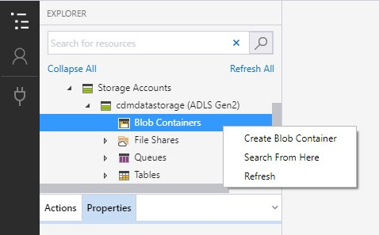

1. In the textbox that appears, enter your preferred name for the blob.
   1. The blob must be named powerbi if it will be written to by a Power BI Dataflow.
   2. If the blob is just being consumed by Power BI Dataflow its name can be any valid name.

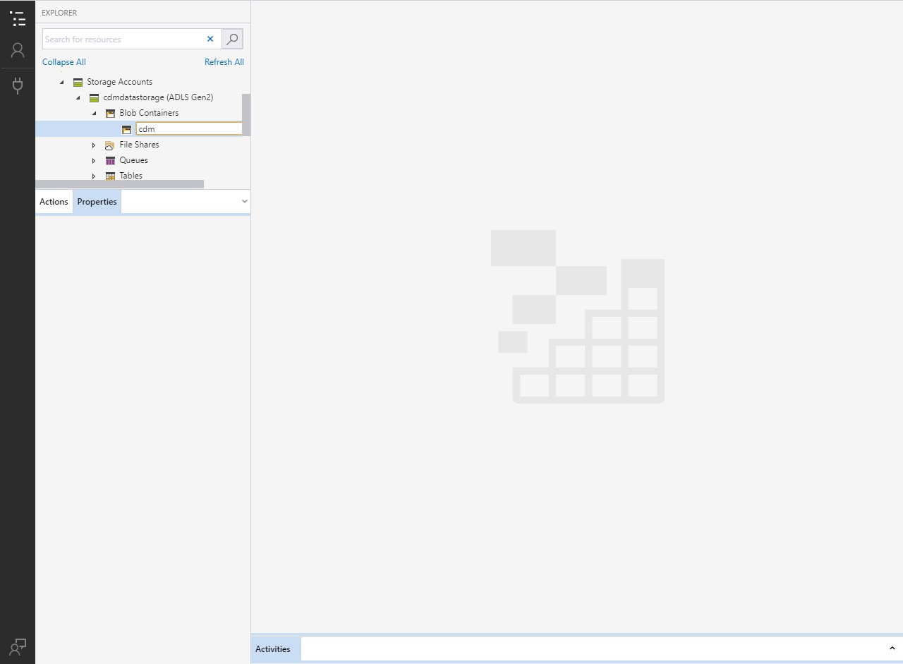

### Blob Security Setup

1. Right click on the newly created blob and select Manage access…

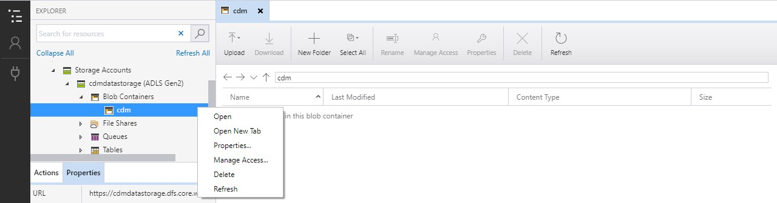

1. Using the GUIDs collected earlier, provide the following access to the following services:
   1. Power BI Premium and Power BI Service (Both require the same access)

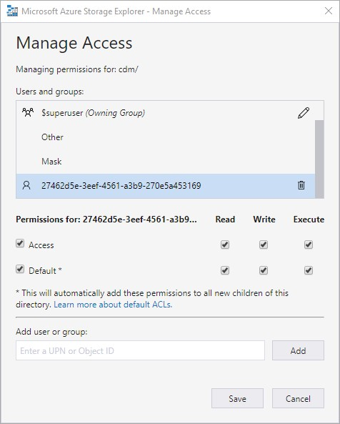

* 1. Power Query Online

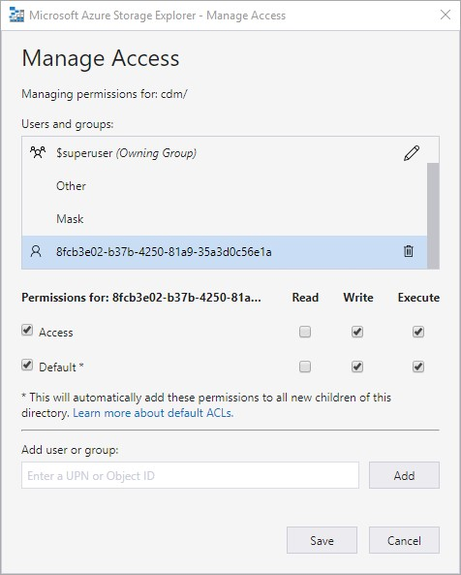

1. Grant the following access to the Other Group:

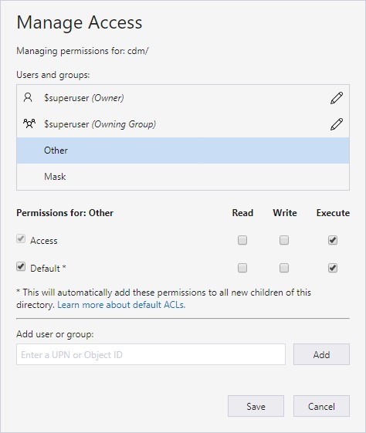

### Folder Setup

1. Inside the blob within Azure Storage Explorer press the New Folder button.
2. In the New Folder dialog, enter your preferred name for the folder. Then press OK.

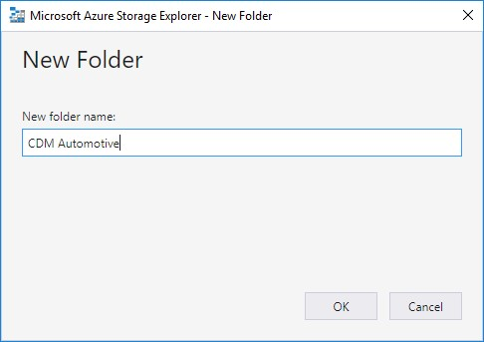

1. Refresh the current view to see the newly created folder.
2. Open the newly created folder.
3. Upload the model.json file. Refresh the view if asked or the file does not appear and no errors have occurred.

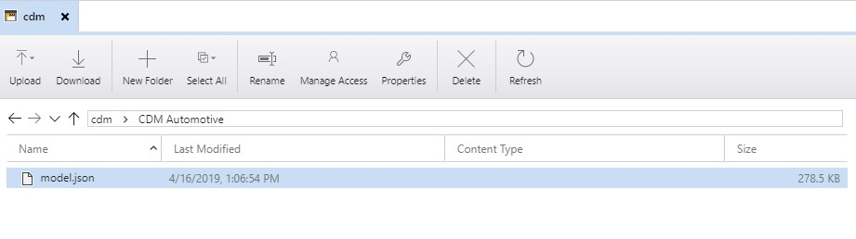

1. Press the New Folder button and create folders for all tables in the model.json file. Refresh as needed to verify that the folders created successfully.

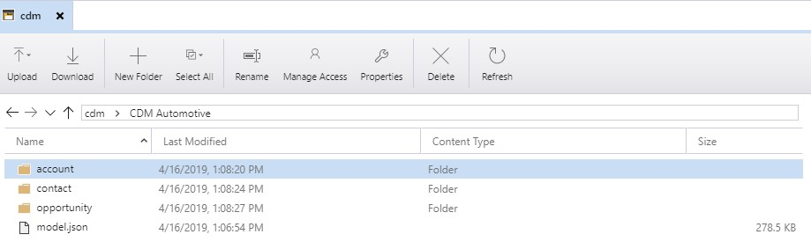

1. The basic structure for the CDM folder is complete and the model.json file can be referenced in a Power BI Dataflow. CSV files can be uploaded within each folder to add data to the Dataflow and the partition property within the model.json file can assist the Dataflow with identifying the latest data file.

## Additional Instructions

### Identify your Power BI tenant

1. Login to powerbi.com.
2. Click the ‘?’ icon in the upper right-hand corner of the screen.

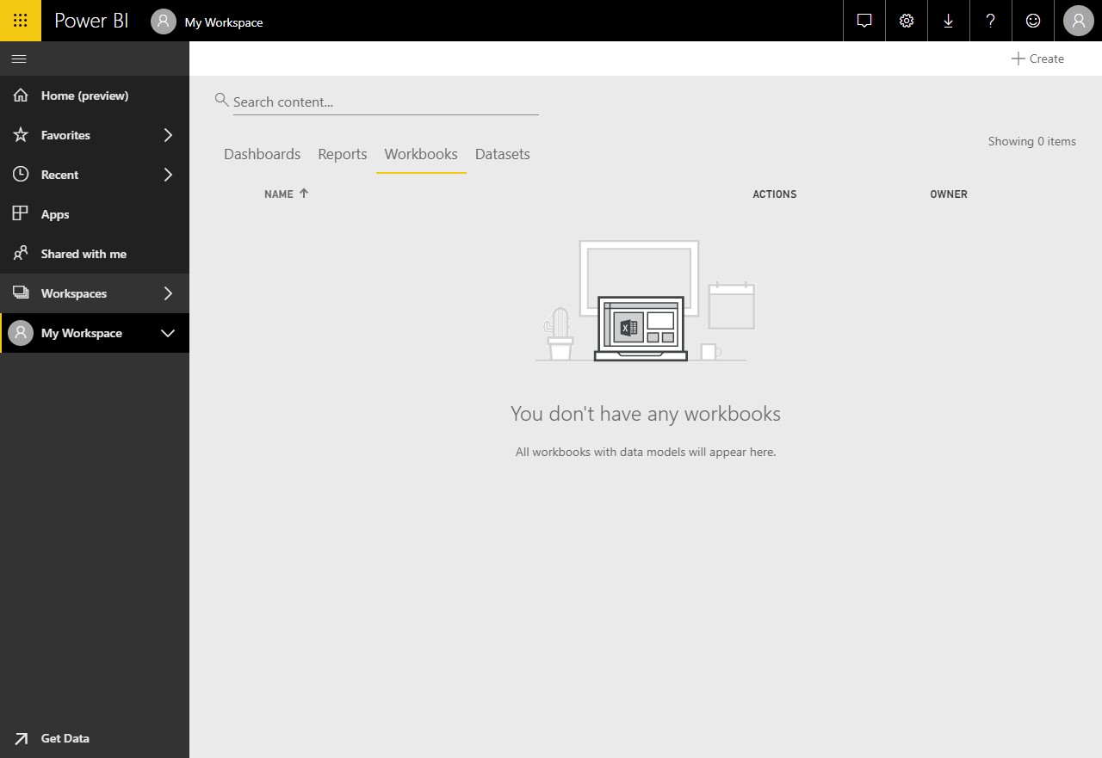

1. Click About Power BI in the dropdown menu that appears.

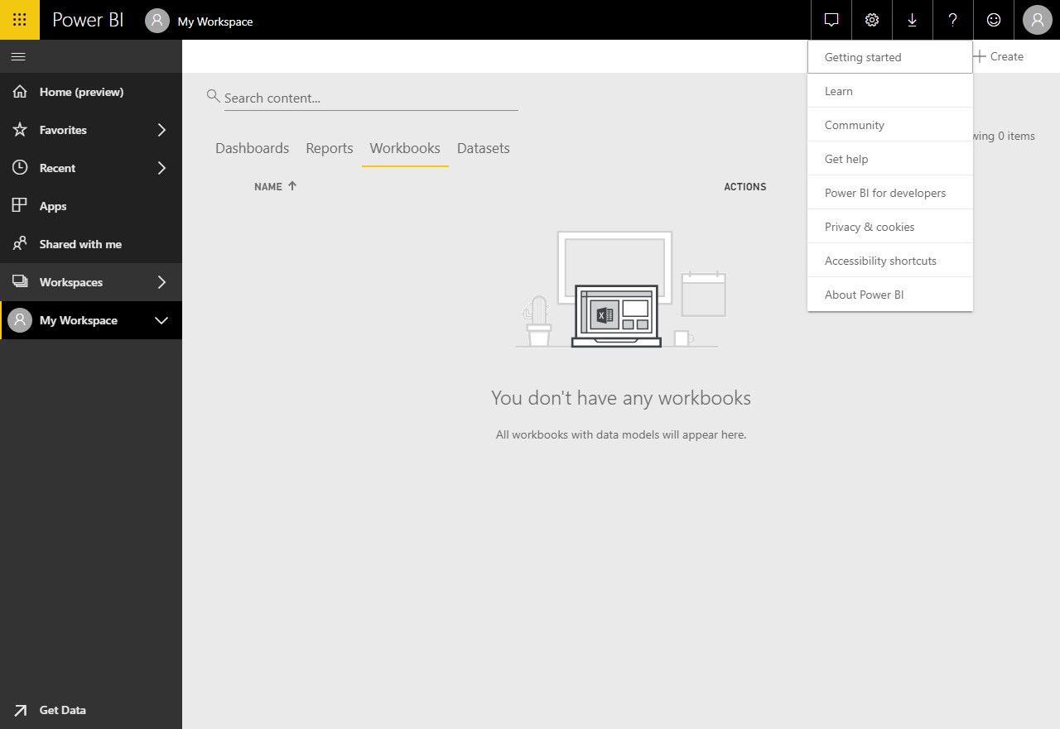

1. The dialog that appears will display the location in which your Power BI data is stored.

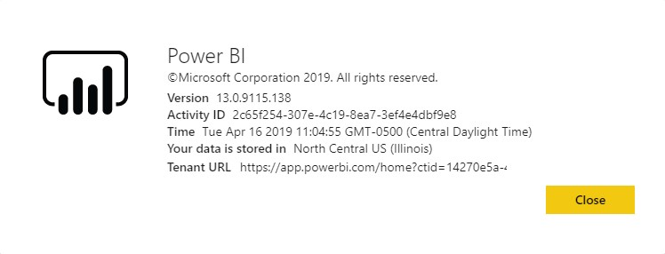

# FAQ

#### Q: What is Common Data Model for Nonprofits?

A: The Common Data Model for Nonprofits is an open source nonprofit data schema published to GitHub. It was launched in November 2018 at the NetHope Summit in Dublin, Ireland and represents a best-in-sector data schema developed by nonprofit thought leaders and practitioners to support nonprofits and vendors serving them in achieving affordable data interoperability.

The CDM for Nonprofits currently includes 94 tables and ~1600 columns that span Program Delivery, Constituent Management, Award Management, Fundraising, Volunteer Management, Nonprofit Operations, and Insights and Impact.  Our goal is to provide nonprofits and partners alike with a data schema that can be leveraged by any technology or vendor serving the nonprofit sector. Broad adoption of the schema will ensure that nonprofit data is relatable, standardized, and actionable, a core challenge facing most nonprofits across the globe today.

With the Common Data Model for Nonprofits, nonprofits can:

* Extend their platforms and create more dynamic, integrated solutions.
* Leverage and share data from robust sources of public data, such as the CDC disease burden or municipal financial data.
* Focus on the work that matters most: driving impact through world-class program design and results measurement solutions.

#### What is the Microsoft Dynamics 365 Nonprofit Accelerator?

A: The Microsoft Dynamics 365 Nonprofit Accelerator is a suite of functional sample applications developed in Dynamics 365 to serve the nonprofit back office and front lines. The Accelerator serves as building blocks that accelerate partner and nonprofit development of purpose-built nonprofit software. Customers and partners can extend and customize these solutions to their specific requirements. Our goal at Tech for Social Impact is to continue to broaden the Nonprofit Accelerator to cover the most common nonprofit use cases. This Accelerator provides partner software engineers with a head start in developing innovative and purpose-built applications that meet the needs of modern nonprofits.

An integral component to the Nonprofit Accelerator is the Common Data Model (CDM) for Nonprofits, the first common data standard built specifically for and with the nonprofit sector. Openly available on GitHub, the CDM helps organizations standardize, share, and relate data across disparate software applications.

#### Q: What are the core capabilities of the Nonprofit Common Data Model and Dynamics 365 Nonprofit Accelerator?

A: The following represent the core areas of Common Data Model for Nonprofits schema:

* **Constituent management:** 360-degree view and tracking of constituent's profile information, including salutations, relationships, preferences, education, and employment.
* **Donation management:** Tracking donations and donor commitments from individuals and institutions, including one-time and recurring donations, gifts-in-kind, grant payments, and bequests.
* **Fundraising:** Solicitation-to-transaction model that tracks end-to-end fundraising across gift types.
* **Grants/awards management:**Request-to-Awards and Disbursements model to help nonprofits efficiently manage investments, grants, and awards.
* **Program delivery:** Outcome and results-based model helps nonprofits efficiently deliver on their missions, measure results, and communicate their impact. Our Nonprofit Program Design Power Application helps program officers design projects and initiatives, tie them to standard, internal, and external indicator sets like the UN Sustainable Development Goals, and collaborate with project partners.
* **Aligning funds to the results framework:** Organizations can draw a thread across their operations and tie funds from donations and awards directly to programmatic activities and outcomes.
* **Connecting beneficiaries and program delivery:** Nonprofits can track the outcomes and impact of program delivery.
* **Customer engagement and Finance & Operations mapping:** Customers can map key Customer Engagement entities to Finance & Operations entities and tables.
* **Volunteer coordination and membership management:** Functionality optimizes volunteer and membership program management.
* **Best practices and resources:** To support nonprofit’s implementations, the platform includes how-to guides and released new purpose-built nonprofit data schemas, templates, and sample applications that are optimized for interoperability.
* **Data transparency and efficiency:** Interoperability across constituent engagement, program delivery, and finance and operations allows nonprofits to see greater insights, streamline solution implementation and reduce costs.
* **International aid transparency add-on:** Nonprofits can record fundraising activities according to the IATI (International Aid Transparency Initiative) Organizational and Activity Standard, via an optional add-on to the Common Data Model for Nonprofits (available via GitHub).
* **Case Management:** Aids nonprofit program staff in tracking clients and beneficiaries and tying cases to specific beneficiary and program goals.
* **Project Management & Program Design:** Provides a complete delivery framework that tracks activities and progress to a theory of change. This assures delivery of programs that are aligned to indicators and program objectives, budgets, and results.

#### Q: What additional functionality was included in v3.0 of the Dynamics 365 Nonprofit Accelerator?

A: The Nonprofit Accelerator v3.0 release includes:

1. **Additional Program Delivery Investments**
   * Provide nonprofits across the globe with Volunteer Management, Assessment Management, and Frontline Humanitarian Logistics building blocks to modernize and automate program delivery and operations workstreams during a time when nonprofits are under increased pressure to deliver programs with greater efficiency
     + Assessment Management sample app and supporting sample data
2. **Nonprofit efficiency gains**
   * Help nonprofits evolve from homegrown legacy systems and spreadsheets used to manage critical areas of finance, operations, and program delivery
   * Automate workloads and tasks that were highly manual and duplicative in the past
3. **Resource savings and data interoperability**
   * Save nonprofits money on overall data management costs by helping them to the leverage the Common Data Model for Nonprofits, thus ensuring that data in disparate systems is relatable and share in common a standard definition set.
   * Drive more trustworthy and accurate reporting, business intelligence, and data discovery by leveraging the CDM for Nonprofits to enforce standard data definitions across systems.
4. **Platform acceleration to benefit partners**
   * Accelerate development and sustainability of partner solutions aligned to the Common Data Model for Nonprofits and Nonprofit Accelerator in the areas of nonprofit case management, project management, program design, and operations.
   * Increase access of Common Data Model for Nonprofits and Nonprofit Accelerator to global nonprofits of all sizes.
   * Streamline, simplify, and scale the existing Nonprofit Accelerator building blocks, ensuring that partners have all the tools needed to publish finished product to AppSource.

#### Q: What is the Nonprofit Operations Toolkit application (released with v2.3)?

A: The Nonprofit Operations Toolkit helps small nonprofits implement effective project and awards management processes that reduce costs and build trust with funders. The toolkit consists of Power Apps that use familiar tools such Excel and SharePoint to keep critical information accurate and accessible.

This toolkit is built on Microsoft’s Power Platform and integrates seamlessly with Office 365 capabilities.  Though the solution does not depend directly on Microsoft Dynamics and does not require a Dynamics license, certain Power Apps functionality is made possible by the underlying technology of Dynamics 365 Customer Engagement. The toolkit makes use of key tables included in the [Dynamics 365 Nonprofit Accelerator](https://docs.microsoft.com/en-us/common-data-model/nfp-accelerator) including:  Award, Budget, Designation and Delivery Framework.

#### Q: Which nonprofit users will benefit from the Nonprofit Operations Toolkit application?

A: The Nonprofit Operations Toolkit assists several users including the Finance Administrator, Human Resource Administrator, Project Manager, Project team member and the Operations Director or Executive Director. It provides the following functionality:

1. Financial Planning: Basic features covering grants, agreements, cost centers, budgeting, and planning.
2. Funding: Basic features covering funder management, donor reporting, and award management.
3. Project Management: Basic features covering work breakdown, project budgeting, approvals, and T&E management.
4. Cost Management: Basic features covering cost schedules, effort planning, and vendor management.
5. Additional Capabilities: Basic features covering security, document management, multi-currency support, and localized language support.

#### Q: What is the Program Design template application (released with v2.2.3.1)?

A: A Program Design template application that nonprofit program officers will use to populate logframes (logical frameworks), design programs, select indicator sets like the United Nations Sustainable Development Goals (SDGs), and monitor and evaluate program outcomes

* This application provides basic Program Design functionality, including creating and browsing logframes, and browsing indicators.
* A low code/no code Power App to allow partners to accelerate development to help the program side of nonprofit and non-governmental organizations navigate through complex theories of change and logical framework design.
* A workflow that allows program managers to design individual programs from best-in-class internal or external standards, such as the UN SDGs
* A workflow that fosters collaboration with colleagues and external partner organizations via Teams, Office 365, and Power Automate.
* Custom theming and simple reviewer and approver workflows

#### Q: Which nonprofit users will benefit from the Program Design application?

A: There are three primary nonprofit personas served in this application version:

1. **Logframe Creator:** The Logframe Creator (e.g., Technical Coordinator) will use the application to create a logframe which will be used to support a grant application and, subsequently, carry out project activities.
2. **Reviewer:** The Reviewer (e.g., Technical Advisor) will use the application to review and approve a logframe before it is sent to a prospective donor.
3. **Program Manager:** The Program Manager will use the app to check on logframe status to ensure timely delivery to prospective/actual donors.

#### Q: What additional functionality was included in v2.2 of the Dynamics 365 Nonprofit Accelerator?

A: The Nonprofit Accelerator v2.2 release includes:

* **Improved program delivery efficacy and beneficiary outcomes.** Through the CDM extensions and indicator import process, organizations will be able to incorporate measurement with the delivery framework allowing for increased ability to gain insights on progress.
* Increased ability to **track and report on outputs, outcomes and impact** by aligning the Nonprofit Common Data Model and Nonprofit Accelerator to the **United Nations Sustainable Development Goals (SDGs)** including a connector to the SDG Goal, Target and Indicator library.
* Increased transparency and shared learning from program design by extending the Nonprofit Common Data Model with new common **Indicator Library tables** including measurement item, measurement item relationship and measurement item usage.
* Indicator Library tables incorporated directly into the Program Design template application.
* New documentation including how-to guides, user guide, walk through guide and sample data
* Improved **interoperability** of ecosystem solutions by supporting partners aligning their solutions with the Nonprofit Common Data Model and Dynamics 365 Nonprofit Accelerator.

#### Q: What functionality was included in the v2.1 version of Dynamics 365 Nonprofit Accelerator and the Common Data Model for Nonprofits?

A: v2.1 and v2.2 of the Dynamics 365 Nonprofit Accelerator aim to cut costs and boost efficiencies for nonprofits through increased data transparency, streamlined implementation of solutions and increased operability across systems. These releases include:

* **Increased the size of the CDM and added Customer Engagement and Finance & Operations mapping.** With this version, we’ve expanded the toolset of connectors, sample applications and templates that partners can leverage to simplify development of custom solutions for nonprofits and create efficiencies for customers. We’re delivering an additional 54 new custom nonprofit and IATI tables and columns in the latest version to total 1400+ tables and columns, along with mapping of key Customer Engagement entities to Finance & Operations entities and tables. This mapping will be a useful starting point for organizations that intend to integrate Dynamic Customer Engagement and Dynamics 365 Finance & Operations platforms using the Dynamics 365 Nonprofit Accelerator.
* **Increased nonprofit data transparency and efficiency.** Interoperability across constituent engagement, program delivery, and finance and operations will allow nonprofits to see greater insights, streamline solution implementation and reduce costs because mapping is built into the accelerator.
* **Deeper understanding of impact against funding and program delivery.** Enhanced sample application gives organizations a simplified view of Program Delivery and its connections to funding sources and beneficiaries. This will offer deeper, real-time insights and allow nonprofits to identify best practices and maximize return on investment that will drive greater impact against their mission.
* **Deeper integration with ISVs to develop solutions that incorporate the Nonprofit Common Data Model.** Without a dependency on Microsoft Dynamics 365 for Sales and Marketing by adding a new solution layer dependent only on Microsoft's Common Data Service that is not dependent on Dynamics 365.
* **Increased efficiency and cost reduction to support IATI reporting.** IATI is a reporting framework that has a published data standard used across the nonprofit sector to share data and insights. Supporting the IATI standards can be costly and time consuming for organizations. The latest version of the Nonprofit Accelerator includes enhancements around exporting the data, incorporating unique donor requirements, and automatic updates of code lists creating organizational efficiencies and reducing barriers for organizational adoption.

Q: What are the primary partner benefits of Microsoft Dynamics 365 Nonprofit Accelerator?  
Microsoft provides resources to help Business Application partners support digital transformation for nonprofit customers. With these resources, partners can improve time to value for their solutions, simplify integration with applications in the Microsoft ecosystem, and improve connections to third-party nonprofit applications.

* **Nonprofit-specific extensions to the Common Data Model.** Using the Business Application Power Platform, partners can access the model to rapidly develop and implement new applications and solutions, mapping to a common set of business and nonprofit entities such as donor commitment and planned giving.
* **Partners get access to installable solutions** that include pre-built dashboards, workflows, sample data, and other tools to help customers build and deploy nonprofit solutions.
* **Reduced development costs and time to market for nonprofit solutions.** 
  + New nonprofit entities streamline development and deployment
  + Pre-built dashboards and workflows make it easier to build and solutions
  + Sample nonprofit data speeds ability to demonstrate Dynamics 365 value in presales motions
  + Support for industry standards like IATI

For more partner information and sign-up for the Dynamics Insider Program, go to [Partners for Social Impact](https://www.microsoftpartnercommunity.com/t5/Partners-for-Social-Impact/ct-p/Partners_for_Social_Impact) partner community. For nonprofits interesting in accessing nonprofit offers, click [here](https://nonprofit.microsoft.com/register).

#### Q: What is Microsoft’s partner ecosystem?

A: Microsoft is activating its partner ecosystem to deliver these solutions. These nonprofit-serving partners are committing to aligning behind data standards, interoperability, and transparency in their solutions through the Microsoft Dynamics 365 Nonprofit Accelerator. For more information, see the [Partners for Social Impact](https://www.microsoftpartnercommunity.com/t5/Partners-for-Social-Impact/ct-p/Partners_for_Social_Impact) partner community.

#### Q: Can the Common Data Model for Nonprofits be used without Dynamics 365 licenses?

A: Yes, the nonprofit accelerator’s Core and Measurement solution layers are not dependent on Microsoft Dynamics 365 Sales. and can be leveraged to build Model driven and Canvas based Power Apps applications, Azure, and Modern Workplace solutions. For more information, go to [GitHub](https://github.com/microsoft/Industry-Accelerator-Nonprofit/releases).

#### Q: Why would a nonprofit need/benefit from Microsoft Dynamics 365 Nonprofit Accelerator?

A: CRM is the central nervous system of every nonprofit and critical to most mission critical processes֫—fundraising, volunteer optimization, beneficiary management, impact/outcomes analysis. However, seventy-five percent of the largest nonprofits lack a digital transformation strategy (Source: NetHope).

When it comes to technology, solutions designed for nonprofits are often repurposed from products originally intended for for-profit use. Paired with costly configuration fees and systems that are not designed to fully integrate, many nonprofits struggle to see a complete view of their programs and impact because information is trapped in internal silos, inside systems that were not intended for managing a nonprofit.

At Microsoft, we believe technology is a powerful force for empowering people and organizations. To address the above problem, Microsoft’s Tech for Social Impact group created the Dynamics 365 Nonprofit Accelerator, a suite of solutions tailored for the world’s nonprofits to drive insights that will in turn help nonprofits achieve their missions and drive greater impact.

#### Q: What are Microsoft Dynamics 365 solutions in the Dynamics 365 Nonprofit Accelerator?

A: Microsoft Dynamics 365 Nonprofit Accelerator includes powerful Microsoft Dynamics solutions specifically designed for nonprofit program delivery.

Based on the input of nonprofits, the Nonprofit Accelerator puts program delivery and impact measurement in the center of its model. This allows Microsoft’s partners and nonprofits to rapidly create and implement new applications and solutions that help to drive program efficacy and measure the impact against funding goals. Pre-mapped on the Common Data Model for Nonprofits to allow for better data transparency, interoperability across platforms, access to external data sources, and rich insights.

Dynamics features include pre-built dashboards, workflows, sample apps, templates, layouts, and data connectors to help partners and nonprofits:

* Build and deploy nonprofit solutions.
* Improve time to value for their solutions.
* Simplify integration with applications in the Microsoft ecosystem.
* Advance interoperability to third-party nonprofit applications.

#### Q: How do you get access to the Microsoft Dynamics 365 Nonprofit Accelerator?

A: To get access to Dynamics 365 Nonprofit Accelerator, customers and partners can test and learn about the accelerator the following two ways:

1. [AppSource](https://appsource.microsoft.com/en-us/product/dynamics-365/msnfp.msftnonprofitcommondatamodel) via Test Drive (limited access time and no Dynamics 365 subscription required)
2. [AppSource](https://appsource.microsoft.com/en-us/product/dynamics-365/msnfp.msftnonprofitcommondatamodel) Get it Now (Dynamics 365 subscription and/or trial is required)

Full capabilities include:

* Constituent management
* Donation management
* Fundraising
* Grants/awards management
* Program delivery
* Aligning beneficiaries to program delivery
* Aligning funds to results framework
* Volunteer coordination
* Membership management
* IATI processes
* Case Management
* Project Management & Program Design

To utilize the Customer engagement and Finance & Operations One-way Data Integration Templates and mapping, Dynamics 365 Sales and Dynamics 365 Finance & Operations are required. Data Integrator templates are available on GitHub.

Click [here](https://dynamics.microsoft.com/) for more Dynamics 365 information.

To register to access Microsoft nonprofit offers, click [here](https://nonprofit.microsoft.com/register).

Click [here](https://github.com/microsoft/Industry-Accelerator-Nonprofit/releases) for access to the solutions and technical documentation via GitHub.

#### Q: Where is there more technical information about the Dynamics 365 Nonprofit Accelerator and Common Data Model for Nonprofits?

A: Recommended resources:

* [Latest CDM for Nonprofits and Nonprofit Accelerator releases](https://aka.ms/NPLATEST)
* [CDM and Accelerator Walkthrough Guide](https://aka.ms/npawalkthru)
* [How-to Guides](https://aka.ms/HowtoGuide) for how to map and align to the Common Data Model for Nonprofits
* [Nonprofit Accelerator Deep Dive Videos](https://nam06.safelinks.protection.outlook.com/?url=https%3A%2F%2Fvimeo.com%2Fuser104216697&data=02%7C01%7CErin.Mchugh%40microsoft.com%7Cf51fad6ecb31472517d908d8040220fc%7C72f988bf86f141af91ab2d7cd011db47%7C1%7C0%7C637263754473017228&sdata=AwFXcu1f%2B0hiIspldvjE5jHWfrUv5xz6VrC%2BOdKarjc%3D&reserved=0) (via VIMEO)
  + [Constituent Management](https://nam06.safelinks.protection.outlook.com/?url=https%3A%2F%2Fvimeo.com%2F367808829&data=02%7C01%7CErin.Mchugh%40microsoft.com%7Cf51fad6ecb31472517d908d8040220fc%7C72f988bf86f141af91ab2d7cd011db47%7C1%7C0%7C637263754473027221&sdata=Ybd5lHA2ANZvQrrpuoBvooDfc1E4ywBy7iTY6JIo9yU%3D&reserved=0)
  + [Fundraising Management](https://nam06.safelinks.protection.outlook.com/?url=https%3A%2F%2Fvimeo.com%2F368024064&data=02%7C01%7CErin.Mchugh%40microsoft.com%7Cf51fad6ecb31472517d908d8040220fc%7C72f988bf86f141af91ab2d7cd011db47%7C1%7C0%7C637263754473027221&sdata=QYtywFML6phO7ZJpaY6PxNIQJDkjClAESWPIsXPpGRE%3D&reserved=0)
  + [Award Management](https://nam06.safelinks.protection.outlook.com/?url=https%3A%2F%2Fvimeo.com%2F368028620&data=02%7C01%7CErin.Mchugh%40microsoft.com%7Cf51fad6ecb31472517d908d8040220fc%7C72f988bf86f141af91ab2d7cd011db47%7C1%7C0%7C637263754473037217&sdata=aUriF3ZlczNcwgjLp5TDeMIiN2JMX1cHcPT193wueVk%3D&reserved=0)
  + [Delivery Frameworks](https://nam06.safelinks.protection.outlook.com/?url=https%3A%2F%2Fvimeo.com%2F368026422&data=02%7C01%7CErin.Mchugh%40microsoft.com%7Cf51fad6ecb31472517d908d8040220fc%7C72f988bf86f141af91ab2d7cd011db47%7C1%7C0%7C637263754473037217&sdata=YgDOtvbOwlpm1j6kYAAU21pPGz22e2W%2FifuAm%2FJGIdg%3D&reserved=0)
  + [Nonprofit Accelerator v2.2.3.0 update](https://nam06.safelinks.protection.outlook.com/?url=https%3A%2F%2Fvimeo.com%2F398607369&data=02%7C01%7CErin.Mchugh%40microsoft.com%7Cf51fad6ecb31472517d908d8040220fc%7C72f988bf86f141af91ab2d7cd011db47%7C1%7C0%7C637263754473047210&sdata=zy6saPYBGtPL6hDyTO5xV%2F4FvklQEPU5UgqGW6UACC0%3D&reserved=0)
* [Technical details](https://docs.microsoft.com/en-us/common-data-model/nfp-accelerator) on the Nonprofit Accelerator
* [Additional support topics](https://aka.ms/AA5kk74) across all Microsoft Industry Accelerators

#### Q: How do I report issues with AppSource and/or GitHub materials?

A: Please [contact us](mailto:dynindaccsupport@microsoft.com) with issues.

#### Q: How do I engage with Microsoft if I am interested in building on the Dynamics 365 Nonprofit Accelerator and/or Common Data Model for Nonprofits?

A: To engage with Microsoft, [contact us](https://aka.ms/cdmengage).